Byer_Space_Time_Assymetry_Research_CFP

Space Time Asymmetry Research (STAR)
Robert Byer, Sasha Buchman, John Lipa and Ke-Xun Sun (Stanford University)
John Hall (NIST)
Robert L. Byer, Department of Applied Physics, Stanford University
650 723 0226 email: rlbyer@stanford.edu

1. Overview
STAR, a proposed small, self-contained mission of opportunity within the Small Explorer Program, will greatly advance the field of fundamental physics. The #1 astrophysics research objective, as stated in the NASA Science Plan for 2007-2016 is to “Understand the origin and destiny of the universe, phenomena near black holes, and the nature of gravity”. The first two Baseline Objectives for Astrophysics are:

- “Test the validity of Einstein’s General Theory of Relativity;”
- “Investigate the nature of space-time through tests of fundamental symmetries; (e.g., is the speed of light truly a constant?)”
Our mission directly addresses these compelling objectives. STAR will perform a fundamental, precision test of special relativity, by searching for small dependencies of the speed of light c on direction in space and on the motion of the observer, with a sensitivity of 10⁻¹⁸. (All sensitivities quoted in this proposal refer to the relative quantity, Δc/c, where Δc is the sought-after departure of the speed of light from a rigorous constant.) Such measurements have previously only been attempted in ground-based laboratories. Today, realization that the Cosmic Background radiation may provide a suitable reference frame for understanding possible variations in c, coupled with recent developments in miniaturized robust optics, motivate simple, low-cost space borne experiments in this field for the first time. The STAR team is led by Robert Byer, the developer of a small, capable, fully space qualified laser, and includes one of the world’s leading experts in special relativity ground based experiments, John L. Hall (Nobel, physics, 2005). Floyd Stecker (GSFC) has collaborated with Sheldon Glashow, a giant in this field (Nobel, physics, 1979). Partnered with NASA Ames and Goddard, the team is admirably suited to conduct the mission. Previous efforts—limited not by technology, but by ground-based noise factors—have approached sensitivities of only 10⁻¹⁶ with no effect detected. STAR will achieve a two order of magnitude improvement by transplanting this proven technology to the relatively noise-free environment of space. The resulting data set will, for the first time, “map” space-time velocity fluctuations in our sky.

Why is it so important to extend this search by two orders of magnitude?
Special and General Relativity and the Standard Model (SM) of physics all rely on the postulate that the speed of light is invariant, regardless of the relative velocity of the source and observer, the direction of the light beam, or its wavelength. Indeed, the whole of modern physics is based on a class of invariances, or symmetries, describing how all measured quantities are seen by different observers in relative motion, and contained in the famous Lorentz transformations. A verifiable detection of any dependence of the speed of light on motion or direction, the object of this proposal, would signal the first needed modification of special relativity since its inception and would have profound implications for the development of cosmology, high energy astrophysics, particle astrophysics, and basic physics, including particle physics and relativity. While the impact of a successful search would be dramatic, even a null-result would have significant value. An improved upper limit would give new direction to theoreticians and reduce the parameter space available to attempts to unite quantum mechanics, particle physics and gravity.

For most of the 20th century there was no reason to believe that there is a special universal frame of reference. The postulate that all inertial frames are equivalent, never contradicted empirically, has led to many great advances -- especially in general relativity. However, we now know of a unique rest frame: that defined by the cosmic microwave background (CMB) (see experiment foldouts), with respect to which the solar system is moving at a velocity of ~370 km/s. While not proving any breaking of Lorentz symmetry, the existence of this natural frame of rest does re-energize the field of experimental relativity because it provides a rational framework against which to interpret any asymmetry that may be discovered. The Universe is nevertheless isotropic, as far as currently known; a separate, and open, question is whether there is any preferred direction in space. Answering this question is another of the baseline objectives of the STAR mission.

If a century of searches with sensitivities down to 10⁻¹⁶ have found no Lorentz invariance violations, why expect STAR to be successful at 10⁻¹⁸?
The one area of general agreement among the many diverse approaches to Lorentz invariance violation (LIV) theory is the plausibility that the long-sought unification of quantum mechanics and relativity will follow the pattern of the unification of electromagnetic and weak interactions, the so-called electroweak theory of Glashow, Weinberg and Salam, in the 1960’s. Accordingly, the natural scale for variations of the speed of light, for example, is expected to be near the ratio of the electroweak mass to the Planck mass, approximately Δc/c ~ 0.66 x 10⁻¹⁷. While not a firm prediction, this consideration shows that the window of sensitivity opened up by STAR plausibly contains very exciting physics.

It is hard to imagine an area of modern astrophysics that would not be profoundly affected by a confirmed Lorentz invariance violation – the first experimental correction to the principles underlying all of modern physics since their origin a century ago. The main point of the proposed STAR mission is that such experiments are within the grasp of modern instrumentation, placed in the tranquil environment of space and relatively free from the local disturbances that limit ground-based measurements.

As indicated above, even non-detection would call into question assumptions underlying most theoretical developments in this field and provide very meaningful upper limits to the values of parameters in Lorentz invariance violation scenarios developed by a number of theoretical physicists. The formalisms of Colladay and Kostelecky (1998), Robertson
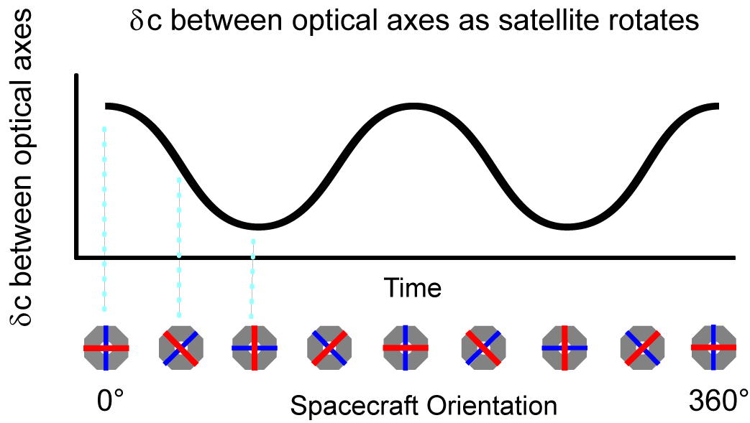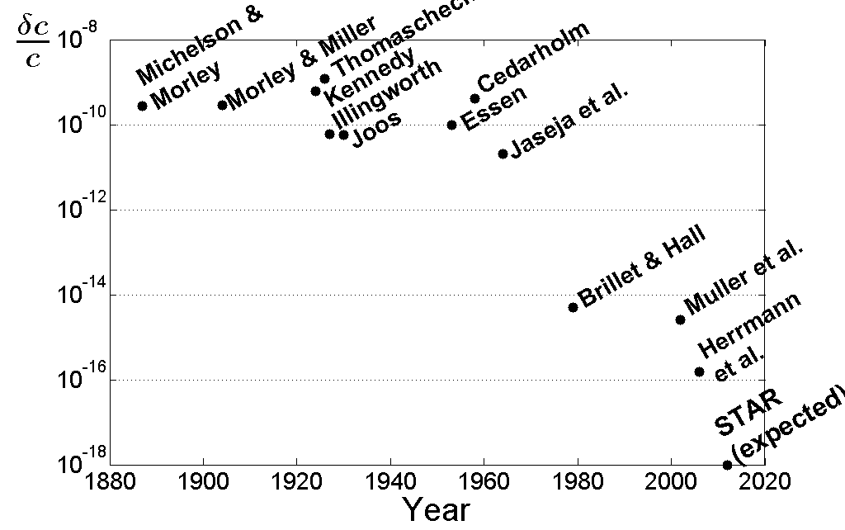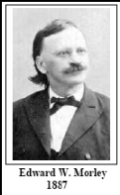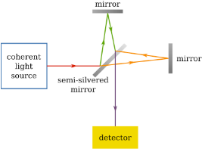
MM STAR Mission Objectives
Measure the anisotropy of c to 10⁻¹⁸
Derive the MM coefficient to ~ 10⁻¹²
Derive the generalized coefficients of LIV
• boost independent: < 7x10⁻¹⁸
• boost dependent: ~ 10⁻¹⁴
Readout Description
Compare the resonant frequencies of two orthogonal high-finesse optical cavities
Signal at 1/2×T_{MM} (T_{MM} = 2 – 20 min)
Configuration conceptually similar to MM
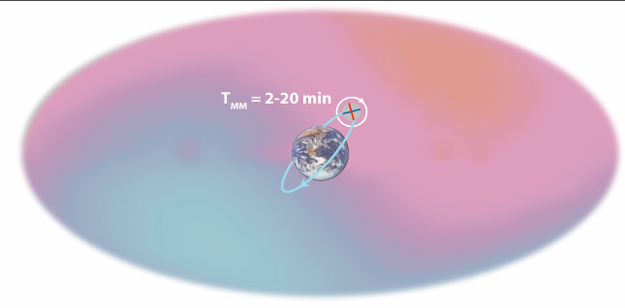
COSMIC MICROWAVE BACKGROUND
History of MM resolution

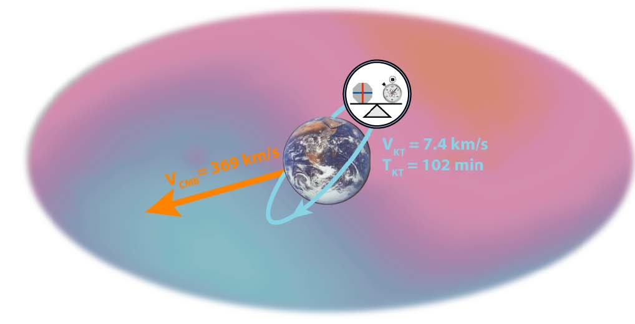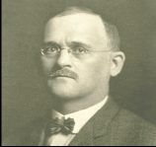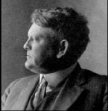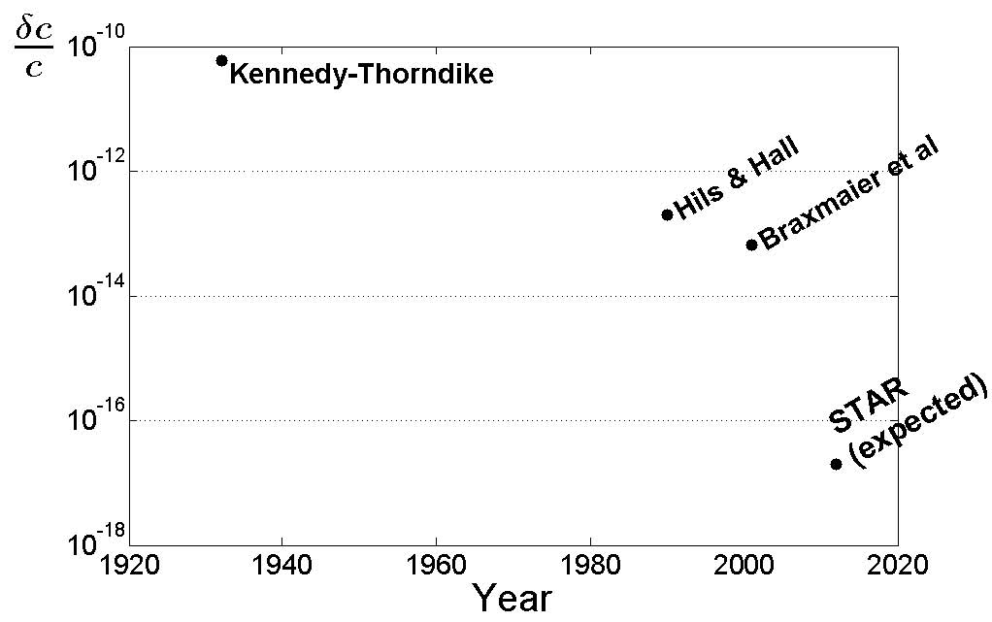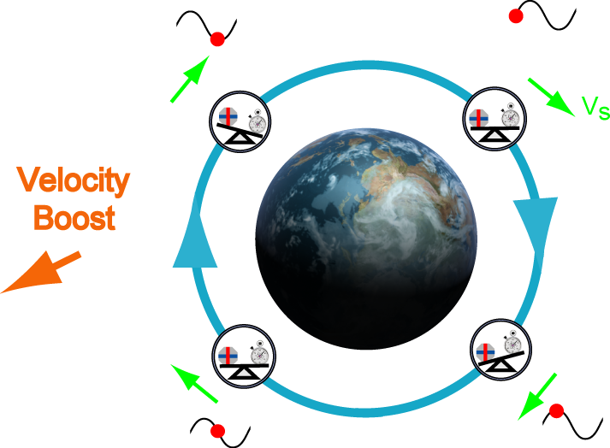
R.J. Kennedy E.M. Thorndike Thorndike
History of KT resolution
KT STAR Mission Objectives
Measure the boost anisotropy of the velocity of light to 10⁻¹⁸
Derive KT coefficient to the corresponding resolution, ~ 7x10⁻¹⁰

Readout Description
Orbital velocity varies with respect to CMB.
If c depends on v_{S} relative to CMB, the resonant frequency of the cavities changes.
Signal at orbital period T_{KT} (T_{KT} ≈ 100 min)
STAR compares the resonance of a cavity to the wavelength of molecular-iodine

(1949) and Mansouri and Sexl (1977) are particularly well suited to observational tests, and are therefore exemplars within this proposal. With either a detection of, or an upper limit on, variations in the speed of light, STAR will be a milestone in modern astrophysics.

2. Scientific Goals and Objectives

Measurement Objectives | Mission Objectives and Relevance | Ground Experiment  (No previous missions) | Improvement Factor Over Ground Experiment | Future Mission  Objectives
Detect LIV (isotropy/anisotropy of c) | δc/c ~ 10⁻¹⁸  Test special relativity | δc/c ~ 10⁻¹⁶ | 100 | δc/c ~ 10⁻²⁰  (LISA is the nearest analogue mission)
Improve KT | ~ 7x10⁻¹⁰  Test symmetry of space time | ~ 10⁻⁸ | ~400 | ~ 10⁻¹¹  (LISA)
Improve MM | 10⁻¹²  Test symmetry of space time | 10⁻¹⁰ | 100 | Improvement on 10⁻¹²  (LISA)
Refine SME | 10⁻¹⁴ to 7x10⁻¹⁸  Improve basic understanding of cosmological parameters | 10⁻¹³ | 50-500 | Improvement on 10⁻¹³  (LISA)
Table 1: Mission Objectives satisfy SMD objectives and synchronize with past and future mission objectives (LIV = Lorentz invariance violation, of which variable c is a special case)

Lorentz invariance is now one of the foundations of modern physics and has been tested with ever more sensitive techniques for 130 years. Historic tests break down into two types, experiments of the celebrated Michelson-Morley (MM) type that look for directional violations of Special Relativity, and experiments of the Kennedy-Thorndike (KT) type which look for velocity-dependent violations. The traditional approach leads to a kinematic view of experimental measurements involving idealized rods and clocks. This situation was analyzed by Robertson (1949) and by Mansouri and Sexl (1977). This RMS model serves as an example of several theoretical frameworks for understanding possible variations of c. It identifies two types of experiments, one primarily associated with rod effects and the other with comparisons between rods and clocks. In their scenario, deviations from Lorentz invariance are parameterized with a simple model involving an anisotropic propagation of the velocity of light and a preferred universal rest frame. In the RMS model we consider a laboratory moving at a velocity v at an angle θ relative to the axis of a preferred frame. Then the speed of light as a function of θ is given by

c(θ)/c = 1 +(β - ε - 1) )v²/c² + (1/2 - β + δ) (v²/c²) sin²θ (1)

where β is the Lorentz contraction parameter, ε is the time dilation parameter, and δ represents transverse contraction, to be determined either experimentally or in the particular theory being considered. In special relativity the last two terms on the right of eq. (1) are zero. In the RMS model a MM experiment can be viewed as measuring the amplitude of the θ-dependent term in eq. (1), while a KT experiment measures the amplitude of the θ-independent term. To evaluate experiments, it is often assumed that the preferred frame is the rest frame of the CMB. In this case the biggest contributor to v is the velocity of the sun along the cosmic microwave anisotropy axis. This number is generally used in the analysis of modern experiments, but it should just be considered as a normalizing convention. For an experiment in space the relative velocity would be modulated at orbital rate as measured in inertial coordinates, giving rise to a periodic variation in the difference frequency between an atomic clock and a cavity oscillator, conveniently measured by STAR.

The basic objectives of the STAR mission are:

Measure the directional dependence of the c with a sensitivity of 10⁻¹⁸ (100x improvement)
Derive the MM coefficient to the corresponding resolution, ~ 10⁻¹² (100x improvement)
Derive the KT coefficient to the corresponding resolution, ~ 7x10⁻¹⁰ (400x improvement)
Derive the corresponding limits on the coefficients of Lorentz violation, in the range 7x10⁻¹⁸ to 10⁻¹⁴ (50x-500x improvement)

Velocity of light:
The STAR experimental approach is simple. STAR measures the anisotropy of the velocity of light δc/c with respect to inertial space using a pair of optical cavities with their axes orthogonal to the spacecraft roll axis. One studies the difference in the resonant frequencies of two cavities as a function of angle and of the velocity of the craft around its orbit. For our configuration the expected signals appear at twice the roll rate with respect to inertial space, and at the orbital period. Precession of the orbit plane over 1 year of operations allows a search in all directions and thus the creation of a “map” of any minute variations in c. The basic measurement does not assume that special relativity is valid and in this sense can be viewed as a theory-independent measurement of any form of anisotropy that can be detected. For example, more complex behavior than that indicated in Eq. (1) could be discovered. This interpretation of the result is independent of any assumptions about the velocity relative to various reference frames but does assume that the apparatus gives a true measurement without any canceling length changes.

Anisotropy, by definition, refers to any departure from being the same in all directions, and therefore it generally cannot be represented by a single number. For convenience one usually considers the simplified case where it can be characterized by a value in three mutually perpendicular directions. To obtain a resolution of 10⁻¹⁸ in one of these directions in a year the noise level of the two-cavity fractional frequency difference, δν/ν, needs to be < 1.6x10⁻¹⁵ in 1 sec. of integration. This assumes a 50% ‘duty cycle’ of good data received on the ground and available for analysis, and a 1-year mission lifetime with a sun-pointing roll axis. Then for a single cavity the fractional frequency noise of the locked laser signal needs to be ~ 1.1x10⁻¹⁵ in 1 sec. (here, δν is sometimes called the beat frequency and δν/ν  is  just  the  frequency  analog  of  δc/c). For more complex forms of anisotropy, the signal seen by STAR would be at higher harmonics. The STAR cavities will act as a form of broad beam antenna converting the anisotropy to measurable signals. From the amplitude and phase of each harmonic in two orthogonal planes, a form of anisotropy ‘map’ will be constructed.

Michelson-Morley coefficient:
This is essentially the same signal as for the velocity of light, but now one assumes eq. (1) is correct and computes the coefficient of the sin²θ term: 1/2 - β + δ. This MM coefficient is larger by a factor (c/v)² relative to the basic measurement, δc/c, to give a parameter that can be compared directly with other experiments. As mentioned above v is taken as the velocity relative to the CMB and any signal detected is referenced to this frame. This implies a (v/c)² value of ~ 10⁻⁶. The resulting MM coefficient resolution would then be in the 10⁻¹² range. Alternatively, one can search for a sin²(θ) dependence along any axis, in which case the total amplitude of the MM term would be constrained.

Kennedy-Thorndike coefficient:
This is similar to the MM coefficient except that one cavity signal is measured relative to an atomic clock, in this case the iodine reference. This clock is expected to have a frequency stability or Allan deviation (AD) of ~10⁻¹⁴ at a measurement time of 100 sec (Ye, 2001), somewhat dependent on construction, but be independent of velocity. The cavity frequency is modulated by the velocity vector changes, δv, of the spacecraft, not the roll. At 1 year the effective AD is ~ 2x10⁻¹⁷. The multiplier from eq. (1) is now c²/vδv which on earth is around 3.3x10⁸. In a circular 1000 km altitude orbit we obtain 2.2x10⁷. The resulting uncertainty in the θ-independent term in eq. (1) is (β - ε - 1) < 7x10⁻¹⁰.

Coefficients of Lorentz violation:
These represent the most general set of Lorentz violations that can occur within the Standard Model Extension that allows for such effects (Colladay and Costeleckey, 1998). To obtain these coefficients the δc/c data is analyzed to derive first and second harmonic information in two orthogonal planes. The coefficients of Lorentz violation are then related linearly to the amplitudes of these harmonics. In the present experiment these coefficients are confined mostly to the photon sector of the SM. Muller (2007) has pointed out that there are some non-negligible contributions from the electron sector of the SM that show up in the beat notes of cavities as well as the photon terms. Thus some of the coefficients of Lorentz violation measured here will be for mixed photon and electron sectors. They go by the notation λ^{IJ} and are relevant as the first order, velocity-independent terms in the SME as applied to cavity clocks. The velocity dependent terms are purely from the photon sector of the model. For our experiment, with a noise level of δν/ν = 10⁻¹⁸, an 8-parameter fit to the δν/ν data would give uncertainties of √8x10⁻¹⁸, assuming no significant systematic errors or correlated errors. The resulting bounds on the coefficients of Lorentz violation would be ~ 7x10⁻¹⁸ for the velocity independent parameters and ~ 10⁻¹⁴ for the velocity dependent parameters. These are the most important results for theorists attempting to unify the SM with gravity.

References
[Allan 1966] Allan, D. W. Frequency deviations in the time domain, Proc. IEEE 54, 221-230, 1966
[Amelino-Camilia 1998] G. Amelino-Camelia , John Ellis, N. E. Mavromatos, D. V. Nanopoulos, and Subir Sarkar, “Tests of quantum gravity from observations of γ-ray bursts.,” Nature 393, 763 (1998)
[Arie & Byer 1992] A. Arie, S. Schiller, E. Gustafson, and R. L. Byer, “Absolute frequency stabilization of diode-laser-pumped Nd:YAG lasers to hyperfine transitions in molecular iodine”, Opt. Lett. 17, 1204-1206, (1992)
[Arie & Byer 1993] A. Arie and R. L. Byer, “Laser heterodyne spectroscopy of ¹²⁷I₂, hyperfine structure near 532 nm,” J. Opt. Soc. Amer. B, 10, p.1990 (1993).
[Brillet & Hall 1979] Brillet, A., and J. L. Hall, “Improved laser test of the isotropy of space,” Phys. Rev. Lett. 42, 549- 552, (1979).
[Colladay 1997] D. Colladay and V.A. Kostelecky 1998, “Lorentz-violating extension of the standard model”, Phys. Rev. D 58, 116002; Phys. Rev. D 55, 6760 (1997).
[Coleman 1999] S. Coleman and S. L. Glashow, “High-energy tests of Lorentz invariance”, Phys. Rev. D 59, 116008. (1999)
[Hils & Hall 1990] D. Hils and J. L. Hall, “Improved Kennedy-Thorndike experiment to test special relativity”, Phys. Rev. Lett., 64, 1697-1700, (1990).
[Drever & Hall 1983] R. W. P. Drever, J. L. Hall, F. V. Kowalski, J. Hough, G. M. Ford, A. J. Munley, and H. Ward. “Laser phase and frequency stabilization using an optical resonator,” Applied Physics B 31, 91- 105 (1983)
[Hall 1999] J. L. Hall, L.-S. Ma; M. Taubman, B. Tiemann, F.-L. Hong, O. Pfister, and J. Ye, “Stabilization and Frequency Measurement of the I₂ Stabilized Nd:YAG Laser,” IEEE Trans. Instrum. Meas. 48, 583 (1999)
[Kennedy & Thorndike 1932] R.J. Kennedy and E.M. Thorndike, “Experimental Establishment of the Relativity of Time” Phys. Rev. 42, 400 (1932).
[Kostelecky 2002] Kostelecky, V. A. and M. Mewes, Signals for Lorentz violation in electrodynamics, Phys. Rev. D. 66, 056005, (2002).
[Leonhardt 2006] V. Leonhardt, and J. Camp, “Space interferometry application of laser frequency stabilization with molecular iodine” Appl. Opt. 45, 4142 (2006)
[Ludlow 2007] A. D. Ludlow, X. Huang,* M. Notcutt, T. Zanon-Willette, S. M. Foreman, M. M. Boyd, S. Blatt, and J. Ye, “Compact, thermal-noise-limited optical cavity for diode laser stabilization at 1x10⁻¹⁵ ,” Opt. Lett. 32, 641-643 (2007)
[Mansouri 1977] Mansouri, R. and R. U. Sexl, “A test theory of special relativity”, Gen. Rel. and Grav. 8, 497, 1977; ibid, p. 515; ibid, p. 809.
[Michelson & Morley 1887] A.A. Michelson and E.H. Morley, “On the relative motion. of the Earth and the luminiferous ether” Am. J. Sci. 34, 333 (1887).
[Mattingley 2005] D. Mattingley, “Modern tests of Lorentz invariance,” Living Rev. Relativity 8, 5 (2005)
[Muller 2007] H. Muller, Paul Louis Stanwix, Michael Edmund Tobar, and Eugene Ivanov, Peter Wolf, Sven Herrmann, Alexander Senger, Evgeny Kovalchuk, and Achim Peters, “Tests of Relativity by Complementary Rotating Michelson-Morley Experiments, ” Phys. Rev. Lett. 99, 050401 (2007)
[Numata 2004] K. Numata, A. Kemery, and J. Camp, “Thermal-Noise Limit in the Frequency Stabilization of Lasers with Rigid Cavities”, Phys. Rev. Lett. 93, 250602 (2004)
[Robertson 1949] H. P. Robertson, “Postulate versus Observation in the Special Theory of Relativity” Rev. Mod. Phys. 21, 378 (1949).
[Sampas 1993] N. M. Sampas, E. K. Gustafson, and R. L. Byer, “Long-term stability of two diode-laser-pumped nonplanar ring lasers independently, stabilized to two Fabry-Perot interferometers”, Opt. Lett. 18, 947 (1993)
[Sato 1972] H. Sato and T. Tati, Prog. Theor. Phys. 47, 1788 (1972)
[Smoot 1991] G. Smoot, et al. “Preliminary results from the COBE differential microwave radiometers - Large angular scale isotropy of the cosmic microwave background, ”Astrophys. J. 371, L1 (1991)
[Stecker 2001] F. W. Stecker and S. L. Glashow 2001, Astropart. Phys. 16, 97.
[Ye 2001] J. Ye, L.-S. Ma, and J. L. Hall, “Molecular Iodine Clock”, Phys. Rev. Lett. 87, 270801-4, (2001)
[Young 1999] B. C. Young, F. C. Cruz, W. M. Itano, and J. C. Bergquist, “Visible Lasers with Subhertz Linewidths,” Phys. Rev. Lett. 82, 3799 (1999)

