Explorations of the Massive Molecular Reservoir
at The Galactic Center
An Astro2010 Science White Paper
Mark Morris, Eric Becklin, Andrea Ghez, Donald Kniffen, Suzanne Madden, Gordon Stacey, Linda Tacconi, William Vacca, Mark Wolfire

The Galactic Center: Warm Clouds and Strong Magnetic Fields
With ~ 4 x 10⁷ M of warm molecular gas and dust responding to the deep potential well of the nuclear stellar bulge and the Galactic black hole, the 300-pc diameter central molecular zone (CMZ) of our Galaxy represents the Galaxy’s most massive concentration of dense gas, and is an essential template for understanding the phenomenology of gas-rich galactic nuclei in general. Because it is a few hundred times closer than even the nearest active galactic nucleus or starburst nucleus, the Galactic center (GC) offers us critical information about how the activity of a galactic nucleus is produced by the interactions of the multitude of contributors: the central black hole, massive stars, dense clouds, strong magnetic fields, an intense X-ray background, and other forms of high-energy radiation. Because of the 20 – 30 magnitudes of visual extinction to the GC, its abundant energy is well represented in the IR and submillimeter, where, with anticipated angular and spectral resolution, we have the best opportunity to unscramble the details of this complex region.
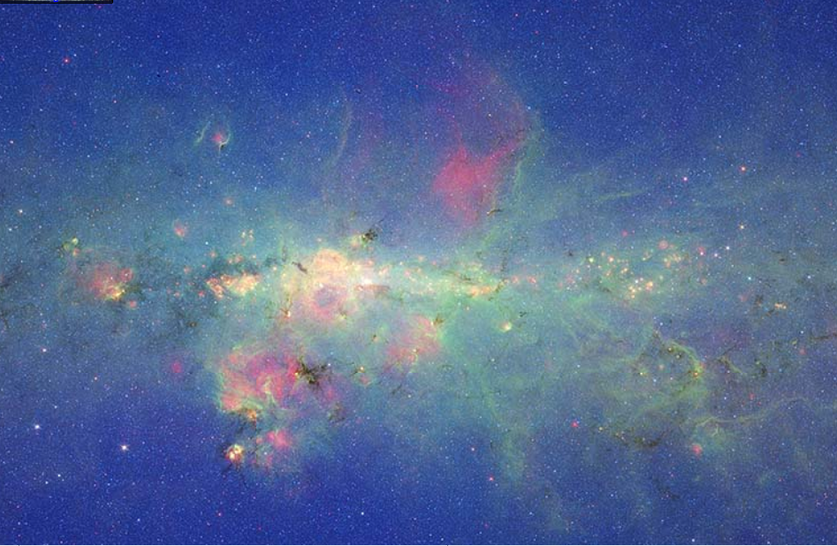
Figure 1: Infrared view of the inner 500 pc of the Galaxy, from the legacy programs of the Spitzer Space Telescope. Blue & green: measurements at 3.6 & 8.0 µm with the IRAC camera; red: 24 µm image from the MIPS camera. The CMZ occupies the central 300 pc of the Galactic plane.
Here, we focus on three important, unsolved questions about the Galactic center interstellar medium that can fruitfully be explored in the coming decade. These questions all relate to interactions of molecular gas that occur almost uniquely in Galactic nuclei, interactions which have a profound effect on the chemical and dynamical evolution of these clouds and on the rate and manner by which these clouds might form stars.
1) What is the dominant heating source for clouds in the CMZ? The temperature in GC clouds averages about 80K, but ranges up to 500K, and about 1/3 of the total gas column is at a temperature of 150 – 200K. These temperatures are far higher than molecular gas in the Galactic disk, requiring a very substantial heating source, especially because the cooling rate of such high temperature clouds is quite high, with C⁺, CO, H₂, and HD all contributing substantially to the radiative cooling. The thermal balance of the GC medium, so important to our understanding of star formation and cloud evolution there, is not yet very well understood, but this is one of the key areas in which we expect substantial progress in the coming decade. The leading candidates for heating are shock heating and X-ray heating (Rodríguez-Fernández et al. 2004), although heating by the dissipation of hydromagnetic waves must be considered as a potential contributor.
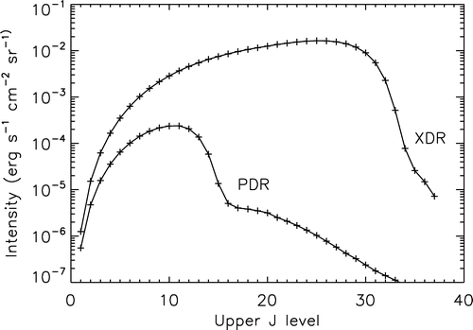
Shock heating can be investigated using the 63 and 146 µm lines of [OI], and comparing them to the 158 µm [CII] line. While the [OI] lines can be produced in both shocks and photodissociation regions (PDRs), the [CII] line strength is much less affected by shocks; use of the two [OI] lines is needed to control for density. Previous observations of the [OI] lines with ISO in a number of isolated locations can be interpreted in terms of a C-shock with a preshock density in the range 10³ – 10⁵ cm⁻³, and shock velocities of 10 – 20 km s⁻¹ (Rodríguez-Fernández et al. 2004, J-shocks are ruled out by the ISO results). It is important to observe the 63 µm [OI] line with sufficient velocity resolution to resolve out the multiple velocity components that are typically seen along a given line of sight through the CMZ, and spread out over a few hundred km s⁻¹.
In this way many shocks can be spatially resolved, since they result from large-scale phenomena such as cloud collisions, or if they are shocks mediated by the galactic bar potential. In those cases, a given shock structure will typically be confined to a single velocity component, and both the spatial and spectral resolution of that component is essential. Internal shocks associated with the strong, supersonic (and probably magnetohydrodynamic) turbulence in GC clouds will not be spatially resolved with any instrument, but the shock heating hypothesis can be tested by seeking a correlation between the turbulent linewidth and the [OI]/[CII] shock diagnostic.
Figure 2: CO line intensities as a function of the upper J level, for a solar metallicity model of density 10⁵ cm⁻³, and a constant impinging energy flux (from Spaans & Meijerink 2008). The stellar spectrum assumed for the PDR illumination is a 30,000 K blackbody.
X-ray heating of GC clouds has been downplayed by Rodríguez-Fernández et al. (2004) because the currently measured X-ray fluxes are not sufficient to counteract molecular cooling at the high temperatures and densities of GC clouds. However, 1) the X-rays are absorbed by galactic extinction up to 2 keV, so only the tip of the X-ray iceberg can be measured, and 2) the neutral iron fluorescence line at 6.4 keV suggests that a burst of X-rays many orders of magnitude brighter than anything currently observed in the GC occurred several hundred years ago, so the heating from such an X-ray flash is still propagating through the CMZ (see below). Thus, the X-ray heating hypothesis warrants renewed investigation.
X-ray dominated regions (XDRs) have most recently been investigated by Meijerink et al. (2007), who predict intensities for fine structure lines and CO lines in both XDRs (assumed illuminated by a nonthermal AGN spectrum) and PDRs (illuminated by a starburst spectrum). They show that powerful diagnostics are available in the ratios of [SiII] 34.8 µm/[CII] 158 µm and [FeII] 26 µm/[CII] 158 µm, as well as in the intensities of high-J CO lines. At typical GC cloud densities, the J=10-9 and 16-15 CO lines are about one and two orders of magnitude stronger, respectively, in XDRs than in PDRs (Fig. 2, from Spaans & Meijerink 2008). As an example, at the one point in the GC where such measurements have so far been reported – the circumnuclear disk – the CO 7-6/CO 16-15 intensity ratio is about 5 (Bradford et al. 2005), which corresponds to a PDR, as expected for this source, which is heated by a combination of a massive young cluster and dissipation of turbulent energy. All of these lines are relatively strong, so extensive mapping will be possible , allowing one to determine whether any XDRs that can be observed are localized or pervasive.
The significance of this question is that it is essential for understanding both the unusual chemistry (c.f., Requena-Torres et al. 2006, 2008) and star formation in the nuclei of galaxies. The high gas temperature affects the balance between gas-phase and grain surface chemistry, and it helps overcome the potential barrier inhibiting many gas-phase reactions. Furthermore, some of the proposed heating mechanisms, notably shocks and X-ray flashes, give rise to local temperature spikes that can have a dramatic effect on the chemistry, not only by speeding up gas-phase reactions, but also by fostering evaporation of relatively volatile molecules from grains. The impact of the high gas temperature on star formation is that it likely skews the initial mass function toward higher masses. The rise of Jeans mass with temperature (and with internal cloud velocity dispersion, which is undoubtedly also quite important) implies that, if the GC is representative, galactic nuclei tend to favor massive star formation. This has important consequences for the energy emerging from galactic nuclei, as function of the mass of stars being formed.
The observational platforms that will advance our understanding of this question in the coming decade are: 1) SOFIA, which can directly observe the cooling lines and shock tracers in the far-IR, and can observe rotational lines of hot molecular hydrogen (Herschel and JWST can also do some of this science, especially in cases where sensitivity is crucial), 2) ALMA, which can provide a high-resolution view of the heating and cooling processes in the GC via submillimeter molecular lines, and 3) the new generation of single-dish submillimeter telescopes, including CCAT and APEX, which can carry out new surveys of molecular lines that are well suited to the characterization of hot molecular material.

2. What are the dynamical and energetic consequences of the strong magnetic field in the Galaxy’s central molecular zone? What is the magnetic field geometry in clouds of the CMZ, and can the revealing fluctuations in the magnetic field direction be measured? As indicated above, the internal motions, and probably much of the heating of Galactic center clouds, are governed by hydromagnetic waves. One of the most significant discoveries with the Kuiper Airborne Observatory was that magnetic field geometries in molecular clouds – particularly in the GC – could be determined by measuring the polarization of thermal far-IR emission from magnetically aligned dust grains (e.g., Chuss et al. 2003). While this work has since been carried on in using submillimeter telescopes, the best place to study warm GC clouds is at far-IR wavelengths. The characterization of the magnetic field orientation in GC clouds has only been done in a few clouds so far, with the finding that the emitting grains are well aligned (presumably by a strong field), the field direction in clouds is remarkably uniform, and the field is predominantly parallel to the Galactic plane (see Figure 3). This has been attributed to the shear of molecular clouds in the strong tidal field of the CMZ. Besides extending such observations to a greater number of clouds, the next step is to study the spatial fluctuations of the field direction. Using the rms fluctuations, in concert with the known velocity dispersions of these clouds, one can apply the Chandrasekhar-Fermi (C-F) method to determine the field strengths. Since Zeeman measures have so far not been very definitive in the GC, largely because of the very broad line widths, the C-F method appears to be the best way to determine the field strength in clouds. This is critical for our understanding of cloud dynamics, star formation, and the relationship of the cloud fields to the strong intercloud magnetic field (Morris 2006).
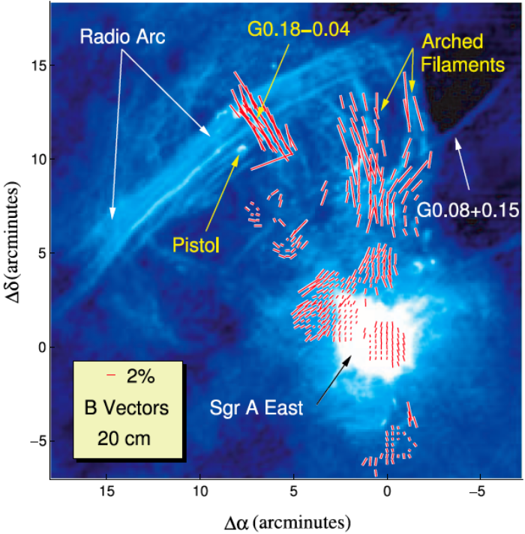
Figure 3: Magnetic field directions inferred from measurements of the orientation of the polarized E-vectors of thermal emission from magnetically aligned dust grains at a combination of far-IR and submm wavelengths (from Chuss et al. 2003). The underlying VLA radiograph, from Yusef-Zadeh et al. (1984), shows 20 cm emission from a 60x60 pc region. The Galactic plane is oriented at a position angle of about 30º east of north, and the Galactic center is located within the radio-bright Sgr A complex.

The circumnuclear disk surrounding the central black hole at a distance of 1 – 5 pc
(0.4 – 2 arcmin in radius) is a particularly interesting case study (Hildebrand et al. 1993), since it comprises the reservoir of dust and gas from which the central black hole may episodically accrete matter, and from which we stand to learn about activity in LLAGNs and about circumnuclear disks in general. Information about the geometry and fluctuations of the magnetic field in this structure will be very important for informing models of the dynamical evolution of this disk, and the eventual accretion arising therein. Furthermore, such observations can elucidate the connection of the toroidal field in this disk to the vertical (dipole) field that apparently dominates the inter-cloud medium (Wardle & Königl 1990).
With a polarimeter, the spatial fluctuations of the field direction could be measured with SOFIA at 50 µm with five times better spatial resolution than has previously been available, and such a measurement cannot be done anywhere else. This is a key issue, because the applicability of the C-F method is maximized when the scale of the fluctuation measurements is matched to the angular scale of the cloud’s velocity fluctuations, and previous observations have probably not reached this scale. Because the continuum emission from GC clouds is strong, these polarimetry measurements will be efficient; an entire cloud could be measured at full resolution in ~10 – 15 hours. Polarimetry with submillimeter telescopes, eventually including ALMA, will also contribute to this important enterprise, but the best way to probe the magnetic field in warm, dense clouds will be via polarimetry at 30 to 100 µm.
3. What is the source of the hard X-rays giving rise to fluorescent X-ray emission from molecular clouds throughout the Galactic center? X-ray studies of the GC with ASCA, Chandra, XMM, and, more recently, Suzaku, have shown that a number of molecular clouds are X-ray reflection nebulae, showing up primarily in the form of fluorescent 6.4 keV line emission from neutral iron (Sunyaev et al. 1993; Koyama et al. 1996, 2008; Yusef-Zadeh et al. 2002; Park et al. 2004; Nakajima et al. 2009). The source of the hard X-rays would have to have been on the order of 10⁶ times brighter than anything now present in the GC, and the scale of the emission implies that the responsible outburst of X-rays occurred several hundred years ago. One exciting possibility is that the X-rays originated from the Galactic black hole, SgrA*, perhaps as a result of a large accretion event. Morphological time variability of the fluorescent Feº line emission, recently discovered by Muno et al. (2007; see also Koyama et al. 2008, Inui et al. 2008), should, in several more years of observation with Chandra, be able to help establish the direction of motion of the X-ray front, and thus it will point back to the source. It is exceptionally important to pursue this phenomenon, because of its implications for accretion onto SgrA*, because of the thermal and chemical effects that such X-ray outbursts inevitably have on molecular clouds, and because of the capability that such a phenomenon potentially provides us for monitoring the past activity of a supermassive black hole.
A fairly strong correlation has been noted between the intensity of the fluorescent Feº emission at 6.4 keV and the intensity of the millimeter rotational lines of the SiO molecule (Martin-Pintado et al. 2000; Yusef-Zadeh et al. 2002; Amo-Baladron et al. 2009). This has led Amo-Baladron et al. to consider the hypothesis that the expanding X-ray front is sufficiently intense to dislodge SiO (and presumably other molecules related to refractory compounds) from grains, and thereby to significantly enhance the abundance of SiO in the gas phase. The SiO/Feº 6.4 keV association can be well investigated by using CARMA and/or ALMA in tandem with Chandra to seek spatial variations in SiO emission that correspond to those of the fluorescent iron emission. X-ray-induced grain evaporation would introduce an altogether new process into studies of interstellar chemistry, so it is important to investigate this correlation in detail along with the X-ray variability.

Summary
- Much can be learned in the coming decade about the interstellar component of the Galactic center, and most of what we learn will enhance our understanding of galactic nuclei in fundamentally important ways.
- The important outstanding challenges that can be met in the coming decade are:
1) to determine the dominant heating mechanism for gas in the CMZ,
2) to characterize the geometry and strength of the magnetic field in GC clouds, and
3) to identify the source and the luminosity of the extreme X-ray outburst in the GC a few hundred years ago, and then to ascertain its effect on interstellar chemistry.
- Several observatories will be essential for responding to the questions raised here. Existing observatories that will be needed include Chandra and CARMA. Near-future observatories that are critical for these studies include SOFIA and ALMA. Important supporting roles will be played by Herschel, JWST, and single-dish submillimeter observatories.

References
Bradford, C.M., Stacey, G.J., Niko la, T., Bolatto, A.D., Jackson, J.M., Savage, M.L. & Davidson, J.A. 2005, ApJ 623, 866.
Chuss, D.T., Davidson, J.A., Dotson, J.L., Dowell, C.D., Hildebrand, R.H., Novak, G. & Vaillancourt, J.E. 2003, ApJ 599, 1128.
Hildebrand, R.H., Davidson, J.A., Dotson, J., Figer, D.F., Novak, G., Platt, S.R. & Tao, L. 1993, ApJ 417, 565.
Inui, T., Koyama, K., Matsumoto, H., Tsuru, T.G. 2009, PASJ, in press arXiv 0803.1528.
Koyama, K., Maeda, Y., Sonobe, T., Takeshima, T., Tanaka, Y. & Yamauchi, S. 1996, PASJ 48, 249.
Koyama, K., Inui, T., Matsumoto, H., Tsuru, T.G. 2008, PASJ 60, S201.
Meijerink, R., Spaans, M. & Israel, F.P. 2007, A&A 461, 793.
Morris, M. 2006, J. Phys.: Conf. Ser. 54, eds: R. Schödel, G.C. Bower, M.P. Muno, S.
Muno, M.P., Baganoff, F.K., Brandt, W., Park, S. & Morris, M.R. 2007, ApJL 656, L69.
Nakajima, H. et al. 2009, arXiv 0811.1830.
Park, S., Muno, M.P. et al. 2004, ApJ 603, 548.
Requena-Torres, M.A., Martín-Pintado, J., Rodrîguez-Franco, A., Martín, S., Rodríguez-Fernandez, N.J. & de Vicente, P. 2006, A&A 455, 971.
Requena-Torres, M.A., Martín-Pintado, J., Martín, S., & Morris, M.R. 2006, ApJ 672, 352.
Rodríguez-Fernández, N.J., Martín-Pintado, J., Fuente, A. & Wilson, T.L. 2004, A&A 427, 217.
Spaans, M., & Meijerink, R. 2008, ApJ, 678, L5.
Sunyaev, R. A., Markevitch, M. & Pavlinsky, M. 1993, ApJ 407, 606.
Wardle, M. & Königl, A. 1990, ApJ 362, 120.
Yusef-Zadeh, F., Law, C. & Wardle, M. 2002, ApJL 568, L121.
Yusef-Zadeh, F., Morris, M. & Chance, D. 1984, Nature 310, 557.

The 35 µm line of [SiII] is also an interesting shock tracer but that line is also produced in both HII regions and PDRs, so the interpretation may not be unambiguous.
Observations of these lines were not done by Spitzer because the continuum levels in most of the candidate XDRs are large enough to saturate the IRS detectors.

