Searching for the Secrets of Massive Star Birth

A White Paper for the Astro2010 Decadal Survey
Submitted to the "Planetary Systems and Star Formation" Panel

John Bally, University of Colorado, Boulder, CO.
Crystal Brogan, National Radio Astronomy Observatory, Charlottesville, VA
Peter Hofner, New Mexico Tech, Socorro, NM
Todd Hunter, National Radio Astronomy Observatory, Charlottesville, VA
Remy Indebetouw, University of Virginia, Charlottesville, VA
Kelsey Johnson, University of Virginia, Charlottesville, VA
Eric Keto, Center for Astrophysics, Cambridge, MA
Mark Krumholz, University of California, Santa Cruz, CA
Nathan Smith, University of California, Berkeley, CA
Contact person: John Bally - john.bally@colorado.edu

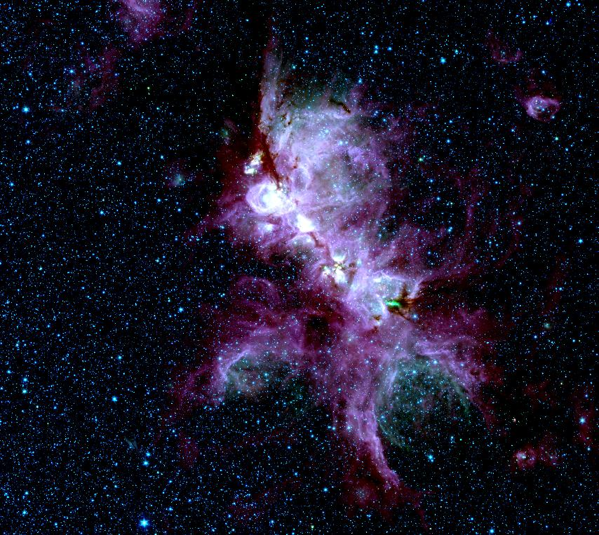
Spitzer Space Telescope IRAC image showing NGC 6334
Introduction: Massive stars play a central role in the evolution of the both the cosmos and the galactic interstellar medium (ISM). The first stars to form in the universe were massive. They were responsible for cosmic re-ionization and its initial chemical enrichment. Massive stars continue to power the “galactic ecology”, the cyclic conversion of the ISM into stars, the enrichment of the ISM by stellar ejecta, and the transformation of gas through ionized, neutral, and molecular phases. Their energetic output dominates the dynamics of the ISM through winds, radiation, and supernovae shells. Massive stars, including the first stars, end their lives as collapsed objects; neutron stars and black holes. Massive stars are important for our understanding of all star formation activity. Their high luminosities are our only means of tracing active star formation from beyond a few kpc in our own Galaxy to deep into the early universe.
The birth of massive stars remains one of the fundamental unsolved topics in astronomy (Zinnecker &Yorke 2007; McKee & Ostriker 2007). Young massive stars are associated with dense gas found predominately in spiral arms such as the Perseus arm at 2 kpc and those in the molecular ring in the inner Galaxy. Massive stars are rare, found in highly clustered and confused environments, and their evolutionary time-scales are very short. The youngest massive stars are so deeply embedded in their dense molecular cores that they often cannot be seen at wavelengths short of the mid-infrared. The long wavelengths, in combination with large distances, requires angular resolution at the limit of current and planned observatories. On the theoretical front, the high temperatures and luminosities, unique to massive stars, require models and numerical codes that can handle self-gravity, ionization, winds, radiation pressure, and magnetohydrodynamics. The huge difference in characteristic time scale between radiative and magnetohydrodynamic processes poses dynamical range requirements that are beyond the capabilities of current numerical codes. Thus, many basic questions concerning the formation and evolution of massive stars remain unanswered.
Among these questions are: What are the initial physical conditions in cores that form massive stars and clusters? Do massive stars form in a scaled-up version of low-mass star formation but in a high-density environment or do they grow by competitive accretion? How does accretion overcome radiation pressure? What sets the upper mass limit for stars? How do massive proto-clusters form? Why is the companion fraction (multiplicity) higher among massive stars than their lower-mass siblings? What role do dynamical interactions play in the formation of massive stars? How does feedback impact star, cluster, and planet formation? How are massive stars ejected at high velocities from their birth clusters? How do massive stars form in extreme environments such as in the circum-nuclear central parsec of the Milky Way and in the super-star-clusters of starburst galaxies? What roles do massive stars and star clusters play in the formation and evolution of super-massive black holes and AGN?
In posing these questions, we note two white papers that cover related but complementary topics: "Fragmentation in Molecular Clouds and the Origin of the Stellar IMF" by Carpenter et al. and "Young Stellar Clusters and Star Formation Throughout the Galaxy" by Feigelson et al..

1. What Initial Conditions Form Massive Stars and Clusters? What are the properties of massive cores in molecular clouds? In one view, cores are long-lived, turbulence-supported objects that form individual (or a few) massive stars in a scaled-up version of low-mass star formation (“monolithic collapse scenario” - McKee & Tan 2003). In a contrasting view, cores are short-lived and transient (Vazquez-Semadeni et al. 2007), massive stars form in dynamic environments and compete with sibling stars for the accretion of material from the core (“competitive accretion scenario”; Bonnell, Bate, & Zinnecker 1998). Measurements of cloud core lifetimes, physical conditions, and evolutionary state may be able to discriminate between theories and answer questions like: Why are some molecular cores forming massive stars while others are not? What are the physical properties that distinguish them? Will a massive core that is not currently forming massive stars do so in the future and on what timescale? The first step to answering these questions is to identify an unbiased sample of massive molecular cores with and without massive protostars.
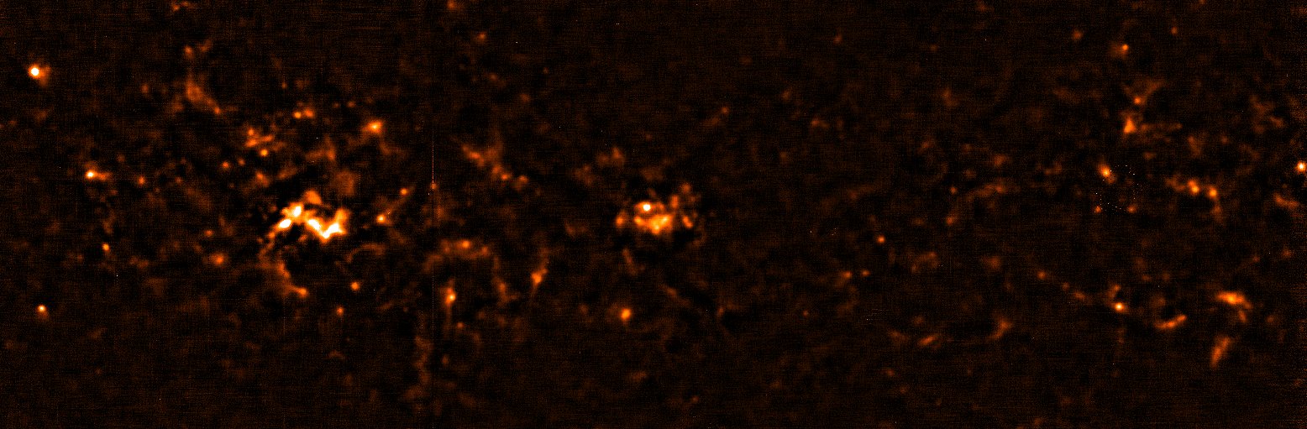
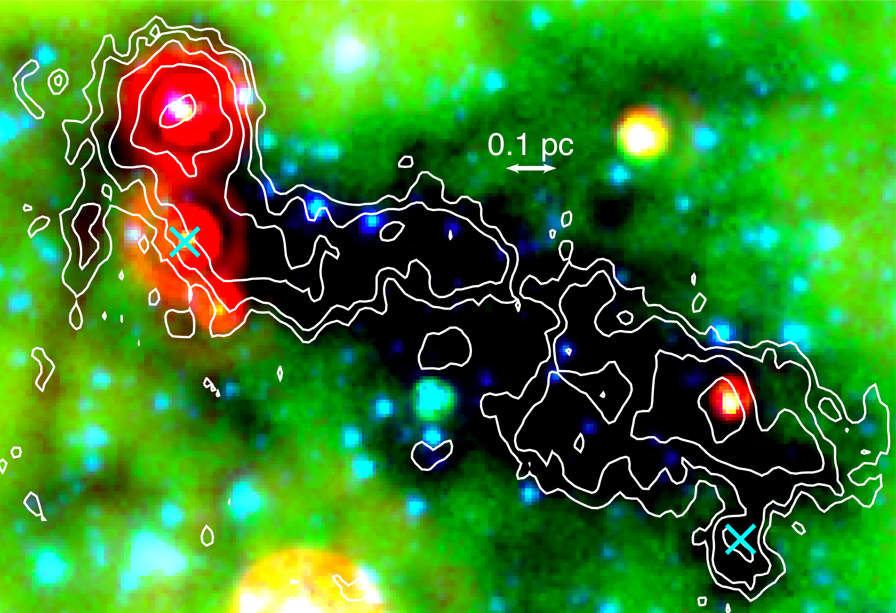
Panchromatic surveys of infrared dark clouds (IRDCs) seen in silhouette against the Galactic mid-IR background, and blind mm/sub-mm dust continuum surveys will provide such samples. Only a few of the thousands of cold (T_{dust}~ 20 K) IRDCs observed by Spitzer have been studied in detail. These contain dense (n > 10⁵ cm⁻³) sub-mm dust cores with sizes < 0.1 pc (e.g. Rathborne et al. 2006). Cores within an individual IRDC show a range of evolutionary states as inferred from the presence/absence of broad molecular lines indicating outflow and/or infall (Rathborne et al. 2005, Beuther & Sridharan 2007), extended 4.5 μm emission from molecular shocks (Cyganowski et al. 2008), H₂O and CH₃OH maser emission, or compact 24 μm sources (Fig 1). The Bolocam Galactic Plane Survey (BGPS – Ginsburg et. al. 2009) has detected over 5,000 dust cores at 1.1 mm in the northern Galactic plane, many coincident with IRDCs (Fig 2). During the next decade high resolution cm to near-IR follow-up observations beyond our current capabilities will be required to characterize these cores in terms of their physical properties, evolutionary stage, and content of young stars.
Figure 1: Spitzer GLIMPSE image of the IRDC G19.30+0.07 with RGB mapped to 24, 8, and 3.6 μm with VLA NH3 (1,1) contours from Devine et al. (2009). Cyan symbols show the locations of H₂O masers.

2. How Do Massive Stars Form? Due to their high temperatures and luminosities, massive stars impact their natal environments dramatically by heating their surrounding molecular cores to much larger temperatures and to larger distances than low mass stars. Temperatures of 10² K to more than 10³ K melt ice mantles on dust grains, drive complex organic chemistry, and increase the gas-phase abundances of complex species (van Dishoeck & Blake 1998). These “hot cores” are visible in thousands of spectral lines that trace the kinematics of infall and outflow, probe the physical conditions surrounding the protostar, and identify its evolutionary state. Hot cores exhibit a wide range of excitation conditions and abundances of various molecular species (Fig. 3). Do they correlate with the accretion rate, instantaneous spectral type of the central object(s), or other properties?
Figure 2: A 2.5º by 0.8º region at l=30º at 1.1 mm from the BGPS (Ginsburg et al. 2009).

While massive stars probably accrete from protostellar disks as do low mass stars, such disks must be more massive, short-lived, and be externally-ionized by UV. Although massive disks have been reported in the literature, few have been studied in detail (e.g. Brogan et al. 2007, Fig. 3; Araya et al. 2008). Measurements of resolved disk properties can be used to discriminate between massive star formation models (e.g. Bally & Zinnecker 2005). However, the large continuum opacity of the inner disk may prevent observing accretion directly. With column densities up to 100 g cm⁻² in the inner few 100 AU, dust will be optically thick at λ < 3 mm and will prevent the escape of line emission (Krumholz , Klein, & McKee 2007). Therefore, <100 AU resolution at the long wavelength end of the millimeter regime will be crucial for probing the inner disks of forming massive stars.
Figure 3: Left: SMA 870 μm (black contours) and VLA 3.6 cm (green contours) image of CepA-East at 710pc, showing chemical and kinematic differentiation between two barely resolved protostars (Brogan et al. 2007). Right: Hot core submillimeter spectrum of the HW2 region (Brogan et al. 2008).

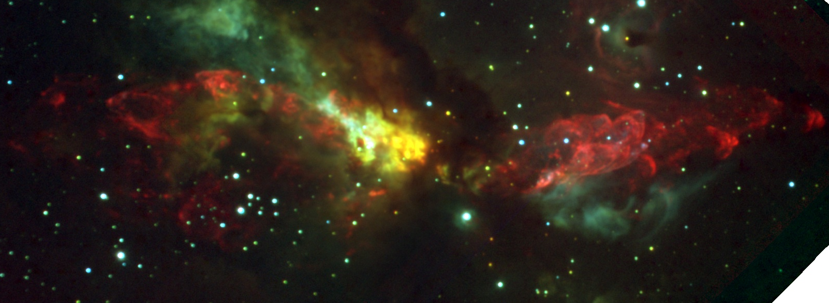
Massive disks lead to interesting consequences. Their fragmentation can form binaries, triples, or multiples (Kratter & Matzner 2006) as often seen in observations (Kouwenhoven et al. 2007; Sana et al. 2008). Massive disks can encourage the capture of sibling cluster stars into non-coplanar, eccentric orbits, contributing to high multiplicity (Moeckel & Bally 2007). Whether the high observed multiplicity among massive stars is due to disk behavior or another cause, it may lead to other phenomena unique to massive stars. The Cepheus A outflow (Fig. 4) has been modeled as the product of a pulsed, precessing jet launched by a massive star whose disk is torqued by a capture–formed companion (Cunningham et al. 2009). Ejection of the massive stars BN, I, and N in Orion a mere 500 years ago may have triggered the BN/KL outflow and its fingers of shock-excited H₂ (Gomez et al. 2008; Bally 2008). Are such interactions responsible for ejecting massive high-velocity stars and forming short-period massive binaries (e.g. Gualandris et al. 2004)? More observations are required to see if such interactions are common.

Figure 4: The Cep A East outflow complex (d = 710 pc) in the near-IR: 1.2 μm (blue), 1.6 μm (green), and narrow-band 2.12 μm H₂ (red).

Once a growing protostar reaches the mass of an early B star, it will be hot enough to produce a hypercompact HII region. Accretion must continue if the star is to become an O star; thus its accretion disk is expected to be at least partially ionized. Both ionized accretion (Keto 2002) and outflow (Keto 2007a) are possible. Massive protostars can continue to grow until their increasing Lyman continuum luminosity drives the ionization front beyond the gravitational radius where the escape speed is greater than the sound-speed in the HII region (Keto 2003). Since most massive stars form in clusters, the gravity of the central cluster rather than an individual star may set the gravitational radius. As the most massive stars in a compact cluster reach their Eddington luminosities, radiation pressure may re-direct the accretion flows from these stars onto less massive objects, thereby encouraging the growth of siblings to their maximum masses (“cooperative accretion scenario” – Keto & Wood 2006, 2007b). Such processes, along with disk fragmentation, and η-Carina-like instabilities may set the upper mass limit. The formation of all stars appears to be accompanied by a bipolar outflow. Bipolar outflows associated with the most massive stars may be wider and slower than outflows from lower mass stars (Arce et al. 2007). Does ionization and radiation pressure modify outflows? How long do massive outflows live and what shuts them off?

When observed to μJy sensitivity, cm emission is usually detected toward massive young stellar objects (MYSOs; e.g. Hofner et al. 2007), observationally confirming the presence of compact ionized gas associated with accretion/outflow processes. At present only small number of systems can be detected with the VLA and MERLIN (e.g. Reid et al. 2007, van der Tak & Menten 2005, Gibb & Hoare 2007); these studies demonstrate the future potential for understanding this evolutionary stage. Unraveling the chemistry, ionization, excitation, dynamics, and evolutionary state of massive protostars requires sub-arcsecond resolution from far-infrared to centimeter wavelengths.
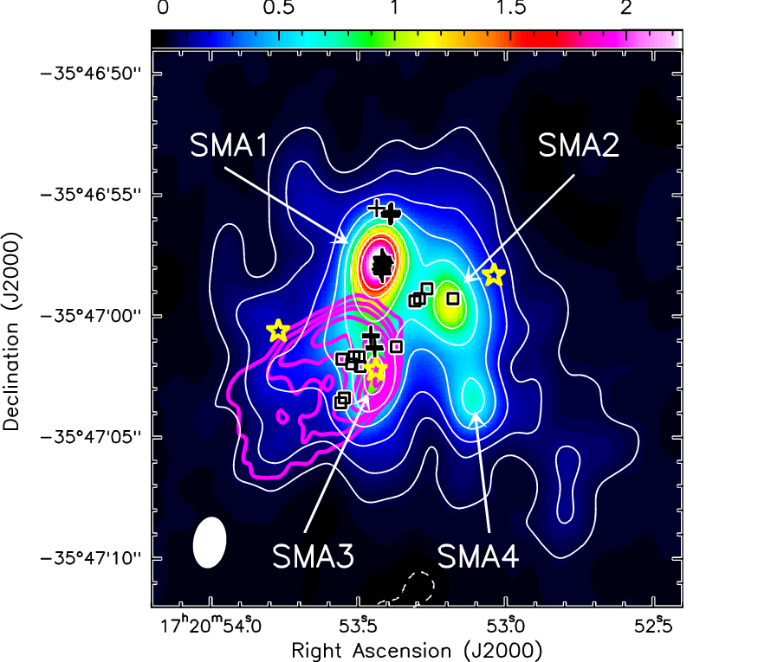
3. What Role Does Cluster Formation Play in the Formation/Properties of Massive Stars? Observations of massive protostars will not yield a complete understanding of their formation without consideration of the cluster environment, and the resolution of multiple protostellar systems. Interferometric millimeter studies of MYSOs have shown that they usually contain multiple, deeply embedded massive protostars with velocity dispersions of a few km s⁻¹ (Hunter et al. 2006, Fig. 5; Rodon et al. 2008). Many such “protoclusters” share striking similarities with the more evolved Orion Trapezium cluster, in terms of the inferred stellar masses, separations (~10⁴ AU), and the accompanying zoo of intermediate- to low-mass stars. A limiting factor in understanding protocluster properties is the lack of resolving power and sensitivity at millimeter to far-infrared wavelengths required for identification of the lower-mass members. Dense natal environments preclude studies between near-IR and soft X-ray wavelengths until later in their evolution when obscuring material has been blown away. Improved understanding of the formation of protoclusters and MYSOs requires spatial resolution better than 50 AU in free-free and dust continuum and in diagnostic molecular lines. Although ALMA will improve our view of protoclusters, even higher resolution will be needed to resolve binary and multiple systems. Proto-binaries with separations similar to θ¹Ori C in Orion (0.03”) at distances of 1 to 10 kpc require resolution of 10 to 1 milli-arseconds.
10,000 AU
Figure 5: SMA 1 mm continuum image of the protocluster NGC6334I. Symbols show H₂O and CH₃OH masers and mid-IR stars; magenta contours show 3.6cm continuum emission from an ultra-compact HII region (Hunter et al. 2006).
High-resolution cm to far-IR observations are essential to answer questions relevant to clusters such as: How and when does mass segregation, the tendency for massive stars to be observed in the cluster center, occur? Do the high mass members of a cluster form near the center, do they migrate there, or is segregation simply the result of there being more stars in the center, increasing the probability of one or more being massive? What can multiplicity reveal about protostar / core collisions and competitive accretion? What role does cluster dynamics play in determining the IMF? Under what circumstances are massive stars ejected? Do low mass stars form first, with star formation terminating after the birth of the first massive stars?

4. What is the Role of Feedback? Feedback from massive protostars into their parent core is a difficult phenomenon to quantify. Massive protostars energize their natal clouds by UV heating, chemistry, and ionization, and mechanically by bipolar outflows. These outflows are not only the major form of early feedback, but reveal much about the accretion process. It is important to determine at what stage a massive protostar begins outflow activity. How are their outflows launched? What roles do magnetic fields play? How much turbulence do massive outflows impart to their neighborhoods? Do outflows transport and disperse organic hot core material?

5. How Does Massive Star Formation Differ in Extreme Environments? Massive stars have formed within a parsec of the 4 x 10⁶ M_{o} black hole (BH) at the Galactic center (e.g. Figer et al. 1999). How do stars form in the extreme shear environment of a circum-nuclear disk? In a similar vein, extragalactic Super Star Clusters (SSCs) represent the most extreme mode of star formation in the universe with thousands of massive stars forming simultaneously in parsec-sized regions. These objects are expected to be common in the early universe during galaxy assembly and may be the progenitors of globular clusters. But what happens to an SSC subjected to the unrelenting pressure of continuing inflow of dense gas? Do they eventually achieve super-dense states where their stars experience collisions? Is AGN activity a consequence of such massive star formation in the extreme? Probing the most extreme modes of massive cluster formation can help to illuminate the relevant processes and answer these questions. Extragalactic observational studies of massive star and cluster formation are essential to probe a larger range of protostellar density, metallicity, and galactic environments than exist in the Milky Way.

Programmatic Recommendations
1. Conduct High-Resolution Surveys of IRDC Sub-mm/mm Dust Clumps and Cores: Efficient mapping of a large number of massive cores requires fast imaging speed (high sensitivity to low surface brightness emission) coupled with high angular resolution (few arc seconds). Both continuum and spectral line observations are needed to derive physical properties. These goals require large collecting area single-dish telescopes equipped with bolometer or MKID focal plane arrays (FPAs) and multi-feed heterodyne cameras. Continuum and heterodyne FPAs are needed on the GBT, LMT, and CCAT at wavelengths ranging from 3 to 0.2 mm to sample the SEDs and measure physical properties of massive molecular cores. Extending these surveys to higher resolution will require interferometers with better brightness sensitivity and wider fields of view. The proposed addition of an ultra-compact E-configuration to the EVLA will greatly improve the surface brightness sensitivity at 7 mm, a wavelength that is critical for disentangling dust and thermal free-free emission. Multi-feed capability is needed on CARMA in the north and ALMA in the south. Simultaneous multi-band observations are also important for excitation studies where accurate relative calibration of different transitions of the same species is crucial.
2. Probe Accretion Onto Massive Stars: Longer millimeter wavelengths (~ 7 mm) are essential for penetrating the high continuum opacities that will plague shorter wavelength observations. The first step is to deploy 7 mm receivers (Band 1) on ALMA, deemed the most scientifically important band lost during the 2005 ALMA de-scope. Though this frequency range is available at the EVLA, the best examples of Galactic massive cluster formation lie in the Southern sky. We need to image protostellar environments from the mid-IR to the mm wavelength range with a spatial resolution better than 100 AU at distances of at least 10 kpc. At the Galactic center (~8.5 kpc), a resolution of 12 mas is needed to resolve 100 AU size-scales at 10 mm. This implies that the EVLA and ALMA baselines need to be increased by a factor of 10. An increase in collecting area is also required to maintain surface brightness sensitivity. These goals can be achieved by the initiative to join ALMA to the VLBA network at 10 mm, while increasing its continuum bandwidth. The North American Array – an initiative to add collecting area to the existing VLBA stations – will be required to achieve the Galactic center goals. This project will allow the event-horizon of the central BH in the galaxy to be resolved for the first time!
3. Resolve Disk Structure, Outflows, and Multiple Massive Proto-Stars: High-angular resolution mid- to far-IR imaging and spectroscopy is needed to study emerging clusters and massive stars. SOFIA will provide high-R spectroscopy with spatial resolution comparable to single-dish mm/sub-mm data, but at limited angular resolution. A 30-m class ground-based telescope at 10 μm can provide sub-arcsecond imaging and spectroscopy of emerging massive stars and clusters. 2 μm extreme Adaptive Optics will probe outflows and emerging low-mass stellar populations. A space-based far-infrared platform working at wavelengths between JWST and ALMA is needed to bridge the gap between emerging stellar SEDs and the sub-millimeter emission from surrounding material.
4. Support Theory, Simulations, and Laboratory work: Theoretical modeling of massive star formation has improved greatly, driven by better observations and advances in computation (e.g. Zinnecker & Yorke 2007; Krumholz & Bonnell 2009). Accretion is not significantly inhibited by the star's radiation feedback (Krumholz et al. 2009). However, our understanding of feedback is still primitive. Better simulation of feedback is the most outstanding theoretical challenge for studies of massive star formation in the next decade. Massive stars have powerful outflows that affect how radiation and gas interact (e.g. Krumholz, McKee, & Klein 2005), but no simulations that model radiation include outflows; and simulations of outflows have not modeled radiation (e.g. Banerjee & Pudritz 2007, Dale & Bonnell 2008). Simulations including ionization (e.g. Dale et al. 2005) did not include outflows or non-ionizing radiation. To model the star formation efficiency for massive protostellar cores and clusters, we must model the full range of feedback mechanisms. Massive protostellar disks are another theoretical frontier. Both analytic (e.g. Kratter & Matzner 2006) and numerical (Krumholz, Klein, & McKee 2007) models suggest that these should be massive and dominated by large-scale gravitational instabilities. However, these calculations do not include the effects of magnetic braking (Banerjee & Pudritz 2007) or magnetorotational instability. Without thorough theoretical exploration of these effects, we will be unable to understand angular momentum transport processes in massive protostellar disks.
The identification of the large number of un-identified mm/sub-mm lines requires extensive laboratory work or the mm/sub-mm spectra of organics. Full analysis of the complex spectra generated by hot cores, solid state features, and complex organics requires determination of transition frequencies, radiative and collisional rate coefficients and other parameters. Both theory and laboratory work in this domain need to be supported.

References:
Araya, E., Hofner, P., Kurtz, S., Olmi, L., & Linz, H. 2008, ApJ, 675, 420
Arce, H. G., Shepherd, D., Gueth, F., Lee, C. F., Bachiller, R., Rosen, A., & Beuther, H. 2007,
Protostars and Planets V, 245
Bally, J. 2008, Massive Star Formation: Observations Confront Theory, 387, 158
Bally, J., & Zinnecker, H. 2005, AJ, 129, 2281
Banerjee, R., & Pudritz, R. E. 2007, ApJ, 660, 479
Beuther, H., & Sridharan, T. K. 2007, ApJ, 668, 348
Bonnell, I. A., Bate, M., & Zinnecker, H. 1998, MNRAS, 298, 93
Brogan, C. L., et al. 2008, ApSS, 313, 53
Brogan, C. L., Chandler, C. J., Hunter, T. R., Shirley, Y. L., & Sarma, A. P., 2007, ApJ, 660, L133
Cunningham, N. J., Moeckel, N. & Bally, J. 2009, ApJ, (in press)
Cyganowski, C. J., et al. 2008, AJ, 136, 2391
Dale, J. E., & Bonnell, I. A. 2008, MNRAS, 391, 2
Dale, J. E., Bonnell, I. A., Clarke, C. J., & Bate, M.R. 2005, MNRAS, 358, 291
Devine, K, Chandler, C. J., Brogan, C. L, Churchwell, E, Indebetwou, R., Shirley, Y 2009, in preparation
Figer et al. 1999, ApJ, 525, 750
Gibb, A.G., Hoare, M.G. 2006, MNRAS, 380, 246
Ginsburg, A. et al. 2009, ApJ (in press)
Gomez, L.,Rodr´ıguez, L. F., Loinard, L., Lizano, S., Allen, C., Poveda, A., & Menten, K. M. 2008, ApJ 685, 333
Gualandris, A., Portegies Zwart, S., & Eggleton, P. P. 2004, MNRAS, 350, 615
Hofner, P. et al. 2007, A&A, 465, 197
Hunter, T. R., Brogan, C. L., Megeath, S. T., Menten, K. M., Beuther, H., et al. 2006, ApJ, 649, 888
Keto, E. 2002, ApJ, 568, 754
Keto, E. 2003, ApJ, 599, 1196
Keto, E., & Wood, K. 2006, ApJ, 637, 850
Keto E. 2007a, ApJ 666, 976
Keto, E. 2007b, The Messenger, 129, 69
Kratter, K. M., & Matzner, C. D. 2006, MNRAS, 373, 1563
Krumholz, M. R., & Bonnell, I.A. 2007, arXiv:0712.0828
Krumholz, M. R., Stone, J. M., & Gardiner, T. A. 2007, ApJ, 671, 518
Krumholz, M. R., Klein, R. I., & McKee, C. F. 2007, ApJ, 656, 959
Krumholz, M. R., McKee, C. F., & Klein, R. I. 2005, ApJ 618, L33
Kouwenhoven, M. B. N., Brown, A. G. A., Portegies Zwart, S. F., & Kaper, L. 2007, A&A, 474, 77
McKee, C. F., & Tan, J. C. 2003, ApJ, 585, 850
McKee, C. F., & Ostriker, E. C. 2007, ARAA, 45, 565
Moeckel, N., & Bally, J. 2007, ApJ, 661, L183
Rathborne, J.M., Jackson, J.M., Chambers, E.T., Simon, R., Shipman, R., & Frieswijk, W.\ 2005, ApJ, 630, L181
Rathborne, J. M., Jackson, J. M., & Simon, R. 2006, ApJ, 641, 389
Reid, M., Menten, K.M., Greenhill, L.J., Chandler, C.J. et al. 2007, ApJ, 664, 950
Rodon, J. A., Beuther, H., Megeath, S. T., & van der Tak, F. F. S. 2008, A&A, 490, 213
Sana, H., Gosset, E., Naze, Y., Rauw, G., & Linder, N. 2008, MNRAS, 386, 447
van der Tak, F.F.S., Menten, K.M. 2005, A&A, 437, 947
van Dishoeck, E. F., & Blake, G. A. 1998, ARAA, 36, 317
Vazquez-Semadeni, E., Gomez, G. C., Jappsen, A. K., Ballesteros-Paredes, J., et al. 2007, ApJ, 657, 870
Zinnecker, H., & Yorke, H. W. 2007, ARAA, 45, 481

