The Direct Approach to Finding Earth-Like Planets
Science White Paper Submitted to
The Science Frontier Panel on Planetary Systems and Star Formation

Sara R. Heap & Marc Kuchner
Sally.Heap@NASA.gov Marc.J.Kuchner@NASA.gov
301-286-5359 301-286-5165
Laboratory for Exoplanets and Stellar Astrophysics
NASA’s Goddard Space Flight Center, Greenbelt MD 20771

15 February 2009

1. Introduction to Habitable Planets and Earth-Like Planets
There is no universally accepted definition of habitable planets or Earth-like planets, so for clarity, we define these terms as follows. Habitable planets are planets that can sustain life: they provide long-term, continuous access to liquid water, and they have access to a source of energy sufficient to drive metabolism. Liquid water is a basic requirement for habitability for several reasons: it is the primary constituent of living cells; it is an essential ingredient of important biochemical reactions such as photosynthesis; it is the “universal solvent”, where simple molecules can interact to form the complex molecules necessary for life; and it works to promote plate tectonics, which is needed for a stable climate. Earth-like planets are habitable planets that have carbon-based life and that use starlight or chemical energy for metabolism. We are interested in detectable habitable planets and planets with life. This means that liquid water needs to be at the surface where it can modify the planetary atmosphere and surface in a way that is detectable remotely.
How do we find habitable planets? Enhanced Doppler surveys or astrometric missions like the Space Interferometry Mission (SIM) cannot determine whether a planet is habitable, because their detections are indirect: they only infer the presence of a planet from the periodic motions of its central star. Parameters derived from indirect observations (planetary mass and orbital parameters) are only marginally helpful for predicting whether a planet is habitable, since (1) the presence of surface liquid water depends on albedo and greenhouse warming as well as on distance from the central star, and (2) long-term climate stability depends on mantle convection via plate tectonics, which in turn depends on planet mass and the radioactive heat content of the planetary interior. All of these factors are unknown. There are still other factors determining habitability; see ref. 1.
To establish the habitability of a planet or the presence of surface life requires direct observation of the planet itself. We need to detect atmospheric water vapor in the planet’s spectrum. We need to search the spectrum for methane produced by methanogens, and for oxygen produced by photosynthesizing organisms.
The rest of this paper develops these themes in more detail. In Section 2, we argue that for each potentially habitable planet, there is a habitable era, mass range, and chemical composition, and that the factors determining its habitability are unknowable. In Section 3, we show how direct, optical observations of a planet itself can tell us whether it is habitable and has life. In Section 4, we discuss other types of observations, both direct and indirect, that will be needed for us to understand why some planets are habitable and others aren’t.
2. Factors Determining Habitability
Habitable Era. It appears that life has thrived throughout the habitable era of Earth despite several catastrophic setbacks. Methane-producing organisms of the Archaea domain (see Figure 1) and oxygen-producing cyanobacteria were present since ancient times, although photosynthesizing organisms did not really take hold until an Earth-age of 1.7-2.2 Gyr, and higher plants and animals appeared only at an Earth-age of 4.0 Gyr. Although higher forms of life seem to be dominant today, microbes such as a species of cyanobacteria called prochlorococcus are still the most successful species on Earth today (10²⁹ organisms!), and cyanobacteria produce up to 30% of the annual production of oxygen.
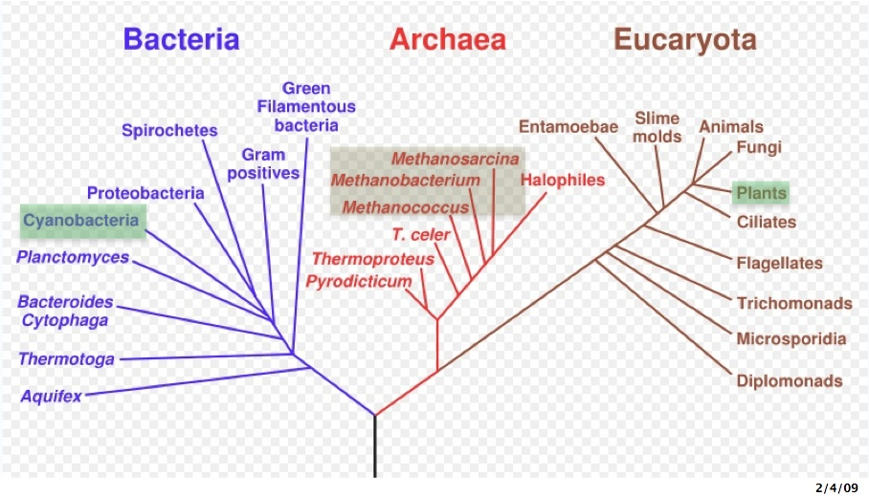
Figure 1. Tree of Life showing the three domains (bacteria, archaea, and eucaryota). The highlighted organisms can alter the composition of the atmosphere in ways that are detectable to a remote observer.
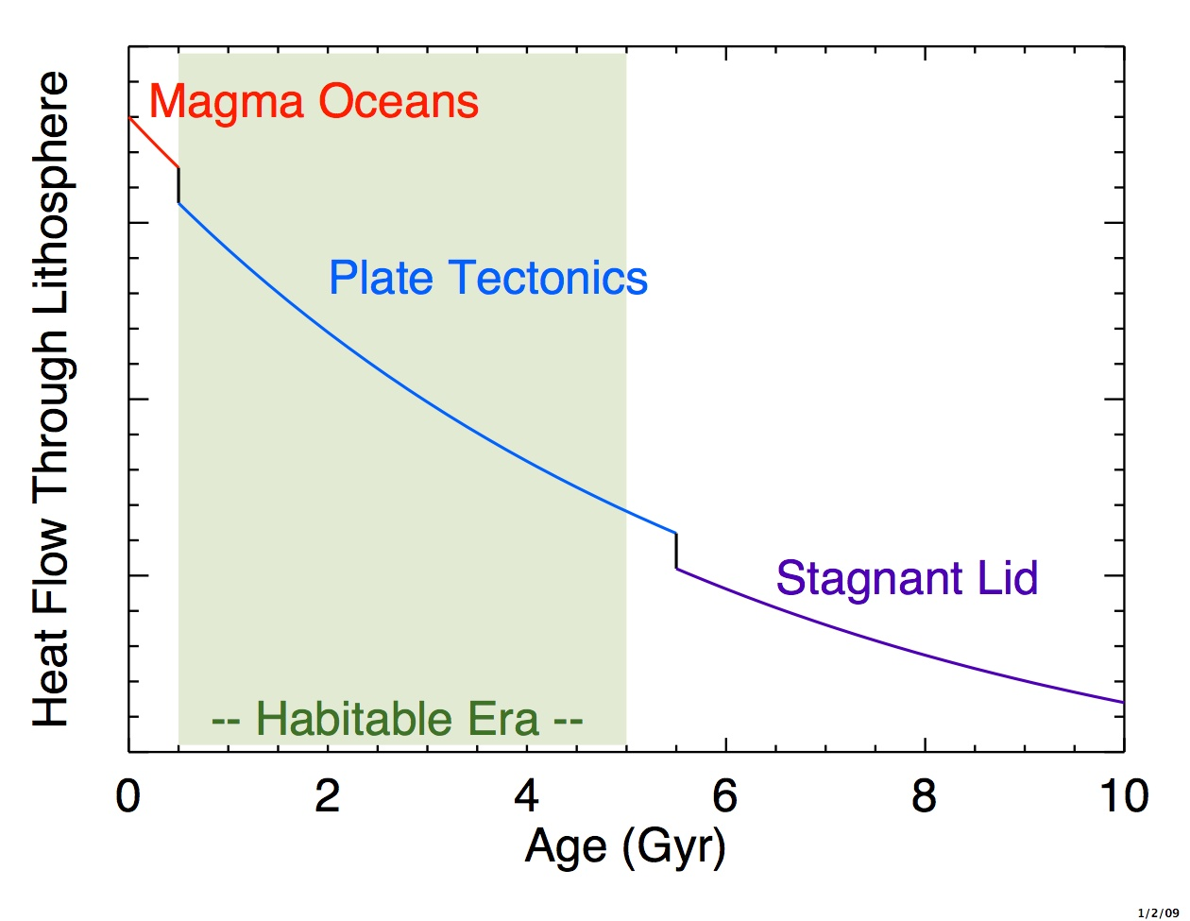
Life is thriving now, but in 0.5 Gyr, the Earth will become inhabitable because the concentration of CO₂ will become too low to support plant life, and in a little over 1 Gyr, warming from an ever brightening Sun will cause the oceans to evaporate. The last nail in the coffin will be the cessation of plate tectonics, which is necessary for a stable climate. Plate tectonics will stop when there is no water to lubricate subduction, and/or radioactive decay in the planetary interior is no longer strong enough to drive plate motions. In other planets, the order of these three catastrophes may be different.
Figure 2. Cartoon (not to scale!) of the evolving mode of mantle convection on Earth.
Thus, there is thus a habitable era for planets (Figure 2). For Earth, the window for life is ~1-5 Gyr in age -- less than half of the Sun’s lifetime on the main sequence. For other planets, the window of life is impossible to predict. We have to observe planets directly to find out to find out if they are habitable and show signs of life, and only after that, correlate these findings with the physical properties (mass, age, and composition) of the planets and their central stars.
Habitable Mass. There is also a habitable range of planetary mass, roughly 1-10 M_{E}. Some scientists argue that “super-Earths” (rocky planets more massive than Earth) are more apt to be habitable because they are more likely to have plate tectonics. Their calculations indicate that plate tectonics are inevitable in super-Earths because the driving forces are stronger, and the plates are thinner and weaker. Others disagree: massive planets will have “stagnant lids” capping the convective currents below; and regardless of mass, rocky planets with some compositions may have pliant crusts that won’t break into plates at all.
But if knowledge of planetary mass is unhelpful in predicting the habitability of rocky planets, neither is a lack of precise knowledge of planetary mass a practical impediment to assessing the habitability of a rocky planet, because spectral habitability-markers (water vapor) and bio-markers (oxygen and ozone) are insensitive to mass of the planet.
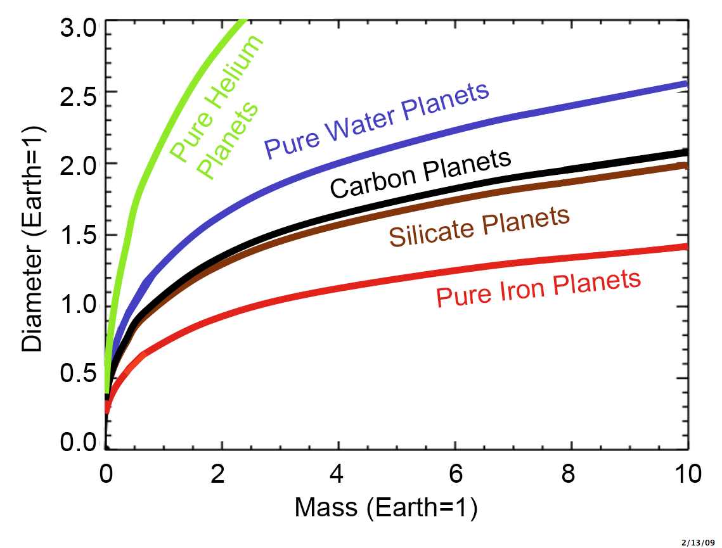
Habitable Composition. There must also be a preferred composition of habitable planets, but this property is literally terra incognita. All we know right now is that the frequency of rocky/icy planets (M< 20 M_{E}) is insensitive to metallicity of the central star,, even though a strong correlation with metallicity holds for giant planets . Soon, we should get general indications of the compositions of exoplanets themselves from the sizes and masses of transiting rocky/water planets discovered by Kepler with radial-velocity follow-up observations. These data can be used to identify the composition-type of the exo-planet as shown in Fig. 3. The mass-radius relationships are degenerate for intermediate radii because of the probability of multi-layered planets. But they will give important constraints for extreme radii (i.e. Iron planets vs. Ocean planets), and transiting planets have already been found where their extreme radii pointed to interesting internal structures (e.g. HD 209458 b, HD 149026 b).
Figure 3. Mass-diameter relation of super-earths. (From Kuchner)
3. Directly Assessing Habitability and the Presence of Life
The UV-optical spectral region is ideal for detecting water vapor and the atmospheric products of life on Earth-like planets. The spectral region, 0.4-1.0 μ, contains absorption bands of H₂O, CH₄, O₂, and O₃. The strongest band of water vapor is H₂O at 0.94 μ, the strongest band of methane produced by methanogens of the archaea domain is CH₄ at 0.89 μ, and the best band for oxygen produced by photosynthesizing organisms is the A-band of O₂ at 0.76 μ. The Chappuis band of ozone at 0.6μ is difficult to detect because it is shallow and broad, plus it is blended with Rayleigh scattering. However, the Hartley band of ozone at 0.2-0.3 μ produces a sharp, deep cut-off in the flux at 0.3 μ that is easily detectable via photometry. Furthermore, it can be distinguished from SO₂ absorption (seen in the UV-blue spectrum of Venus) by the strength, sharpness, and wavelength of the cut-off. This UV ozone absorption feature is important as it brings a 100-fold increase in the sensitivity to photosynthesizing life. The ratio of ozone and oxygen strengths is a measure of the evolutionary stage of life.
Figure 4 shows a simple simulation of the spectral evolution of an Earth-like planet revolving around a Sun-like star at 10 pc, where the evolutionary trends follow those described by Kasting and Kaltenegger et al.. The left-hand column shows the observed spectrum, which is composed of reflected stellar spectrum, Rayleigh scattering, and absorption features formed in the planetary atmosphere. The latter were derived from “curve-of-growth” tables by Des Marais and colleagues. The right-hand column shows the planet spectrum obtained by dividing the observed spectrum by the stellar spectrum.
The UV-optical spectrum is a sensitive diagnostic of life over the full habitable era, which for Earth is roughly 1-5 Gyr in age. At an age of 1 Gyr, methanogens of the Archea domain produced easily detectable quantities of methane. At an age of 2.5 Gyr, oxygen produced by photosynthesizing organisms was on the rise. Ozone absorption in the UV was very strong even though there was not enough oxygen as to be detectable. Today, both ozone and oxygen are clearly visible, but methane is undetectable, because its concentration declined as that of oxygen rose, since methane is easily oxidized.
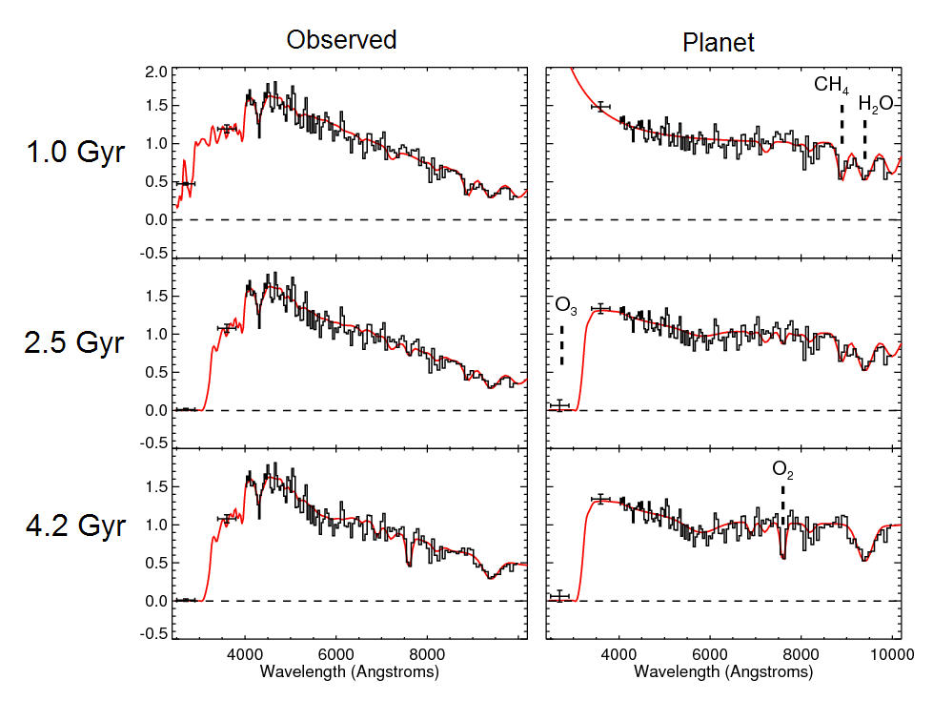
Figure 4. Spectral evolution of an Earth-twin at 10 pc as observed by a 4-m telescope in a 10-day exposure. The red line shows the spectrum without noise, the black line is the observed R=70 spectrum having a S/N=12 per resolution element.

4. Understanding Habitability
UV-optical spectra will indicate whether a planet is habitability and has life. However, knowledge of the physical parameters will be essential to understanding why some planets are habitable or have life, and others don’t. Knowledge of the physical parameters of a planet will also be needed to help interpret the spectral data, confirm its findings, and resolve ambiguities.
Probably the #1 physical property that will be needed is the global average temperature of a planet. The UV-optical spectrum, which is basically the reflected light of the star, cannot be used to measure the temperature of a planet. If the spectrum does not show absorption lines of water vapor, it could be because the planet has no surface water, or it does have water but it’s frozen. (Water-ice has strong absorption lines in the near-IR, but none at wavelengths shorter than 1.0 μ, the long-wavelength limit of an optical detectors (CCD’s)). In cases like these, an infrared interferometer (TPF-I) could resolve this ambiguity by directly measuring the spectral energy distribution of the planet in the infrared where nearly all the thermal flux is emitted. It could also confirm findings from the optical spectrum by observing infrared absorption bands of H₂O, O₃, and CO₂. However, detailed modeling of the optical and IR spectrum together will be needed to verify that the temperature being measured is at the surface rather than at the top of the atmosphere.
The next most important physical parameters that will be needed are planetary mass and orbital parameters. The Exoplanet Task Force highly recommended space astrometry for this purpose.
5. Summary and Conclusions
The studies described in Section 2 strongly suggest that a rocky/water planet could have widely different properties depending on its mass, age, chemical composition, and environment within its planetary system. Therefore, we cannot hope to predict which stars host Earth-like planets, as there are too many factors involved, and nearly all of them are unknowable. The only way to cut through this knotty problem is to observe planets directly. We cannot expect habitable planets to be Earth-twins, so the first planet-observing mission must be an explorer. It should search for planets (including Earth-size planets) orbiting each target star, and if it finds one or more planets, it should immediately obtain the colors and spectra of the whole planetary system via integral field spectroscopy. The rewards from such an approach are guaranteed.
6. Recommendations
1. Stellar Ages. It will be helpful to know the ages of planets, both habitable and inhabitable, in order to learn how the habitable era relates to physical parameters. We can get started on that job now by measuring the ages of candidate target stars, preferably via astroseismological techniques. Astroseismology observations are already being made from the ground with precision RV spectrographs.
2. Interdisciplinary Research. Communications and collaborations of astronomers with geophysicists and paleogeologists should be encouraged. We have much to learn from them.
3. Theory. Theoretical studies of rocky/water planets should be broadened from a detailed study of Earth-twins to planets of different masses, ages, and compositions.
4. Technology. The UV band of ozone discussed in Section 3 can only be observed by optical telescopes using external occulters to achieve starlight suppression. NASA should invest heavily in technology for external occulters. It should also invest in photon-counting CCD’s, particularly p-channel photon-counting CCD’s, which are needed for detection of water vapor.

Acknowledgements. I happily acknowledge the Aspen Center for Physics, where in August 2008, I was introduced to geological and other factors that determine the habitability of exoplanets but are invisible to a remote observer.

References

Gaidos, E. et al. (2005) “Beyond the Principle of Plentitude: A Review of Terrestrial Planet Habitability”, Astrobiology 5, 100
Pepe, F. & Lovis, C. (2008) “Exploring the Limits of Doppler Measurements”, Phys. Scripta T130, 014007
Unwin, S. et al. (2008), “Taking the Measure of the Universe: Precision astrometry with SIM PlanetQuest”, PASP 120, 38
See for example, http://en.wikipedia.org/wiki/Methanogen
See for example, http://en.wikipedia.org/wiki/Cyanobacteria
Schopf, J. W. (2001) Cradle of Life: The Discovery of Earth’s Earliest Fossils, Princeton U. Press
Kasting, J. & Catling, D. (2003), “Evolution of a Habitable Planet”, Ann. Rev. Ast. Astrophys. 41, 429
Ward, P. & Brownlee, D. (2000), Rare Earth, Springer-Verlag, NY
See for example, http://en.wikipedia.org/wiki/Prochlorococcus
Cyanobacteria: Molecular Biology, Genomics, and Evolution (2008) ed. A. Herrero and E. Flores
Kasting, J. (2000) as quoted in “Date set for desert Earth”, http://news.bbc.co.uk/2/hi/sci/tech/specials/washington_2000/649913.stm
Caldeira, K. and Kasting, J. (1992) The Lifespan of the biosphere revisited”, Nature 360, 721
Ward, P. and Brownlee, D. (2002) quoting Kevin Zahnle, in The Life and Death of Planet Earth, Owl Books, New York, p. 144-146
Williams, D., Kasting, J. and Wade, R., (1997) “Habitable moons around extrasolar giant planets”, Nature, 385, 234
Valencia, D. et al. (2007) “Inevitability of Plate Tectonics on Super-Earths”, ApJ 670, L45
Hansen, V. (2008) as reported in http://www.geotimes.org/feb08/article.html?id=nn_tectonics.html
O'Neill, C., A.M. Jellinek, and A. Lenardic (2007) “Conditions for the onset of plate tectonics on terrestrial planets and moons.” Earth Planet. Sci. Lett., 261, 20
Kaltenegger, L. (2009) priv. comm.
Udry, S. (2007) “Statistical Properties of ExoPlanets”, ExoPlanets: XVI Canary Islands Winter School of Astrophysics, Cambridge U. Press, p. 24
Mayor, M. et al. (2009) “A planetary system with 3 super-Earths (4.2, 6.9, and 9.2 M⊕)”, A&A 493, 639
Valenti, J. & Fischer, D. (2008) “Relationship between giant planet frequency and stellar metallicity”, Physica Scripta 130, 014003
Seager, S., Kuchner, M. et al. (2007) “Mass-Radius Relationships for Solid Exoplanets”, ApJ 669, 1279
Moroz, V. I. et al. (1985) “Solar and Thermal Radiation in the Venus Atmosphere”, Adv. Space Res., Vol 5, No. 11, 197
Kasting, J. & Donahue, T. (1980) “The Evolution of Atmospheric Ozone”, JGR 85, 3255
Kasting, J. (July 2004) “When Methane Made Climate”, Sci. Am.291, 78
Kaltenegger, L. et al. (2007) “Spectral Evolution of an Earth-Like Planet”, ApJ 658, 598
Castelli, F. & Kurucz, R. (2004) http://wwwuser.oat.ts.astro.it/castelli
Des Marais, D. et al. (2002) “Remote Sensing of Planetary Properties and Biosignatures on Extrasolar Terrestrial Planets”, Astrobiology 2,153
Canfield, D. (2006) “Gas with an ancient history”, Nature 440, 426
Clark, R. et al. (2007) http://speclab.cr.usgs.gov/spectral-lib.html
ExoPlanet Task Force Final Report (2008) http://www.nsf.gov/mps/ast/exoptf.jsp
Vauclair, S. et al. (2008) “The exoplanet-host star ι Horologii”, A&A 482, 5

