The Importance of Solar EUV and FUV Irradiance Measurements for Space Weather and Atmospheric Modeling

Submitted to: A Decadal Survey Panel on Solar and Heliospheric Physics

Contributors: M. Snow, W. E. McClintock, & F. G. Eparvier
University of Colorado/LASP

Executive Summary:
Extending the data record of solar EUV and FUV irradiances should continue to be a priority of the heliophysics community. Solar spectral irradiance in these wavelength bands is the dominant source of energy input to the upper atmosphere. Understanding both the long-term (climate) and short-term (space weather) variations in the atmosphere is critical for our technological society. NASA does not currently have any FUV irradiance measurements in the pipeline after the SORCE mission. An irradiance monitor could be manifested on a commercial satellite for a modest investment by NASA.

Introduction

Ultraviolet solar irradiance is the primary source of energy input for the upper atmosphere (e. g. Hinteregger, Fukui, & Gilson, 1981). In this context, we divide the ultraviolet spectrum into the extreme ultraviolet (EUV) ranging from 10 to 120 nm, and the far ultraviolet (FUV) ranging from 120 to 200 nm. The strong Hydrogen Lyman alpha line at 121.6 nm is a natural boundary between these two regimes. Figure 1 shows the altitude of unit optical depth for these wavelengths. The solar spectral irradiance (SSI) at these wavelengths shows significant variability at all timescales that we are able to measure, all the way from very transient responses to flares through variation over decades from solar minimum to solar minimum (Snow, McClintock, & Woods, 2010). Variability on the short time scales is an important driver for space weather (Lathuillere et al., 2002). The EUV irradiance variations can drive fluctuations in the density of the upper atmosphere (Lean, Picone, & Emmert, 2009) which affect satellite drag, global positioning, communications, navigation, etc. In fact, forecasting the solar drivers of these upper atmospheric changes was listed as a high priority in the National Space Weather Strategic Plan (1995).

Currently, there are instruments measuring SSI in this wavelength range, and the data record in the FUV extends back almost two solar cycles. There is no continuous EUV data record before 2002 when TIMED SEE began science operations. There has been a tremendous amount of work using proxies to reconstruct the ultraviolet SSI record back to 1947 or earlier for use in climate research (e. g. Krivova, Solanki, & Unruh, 2009a; Krivova et al., 2009b), as well as using these proxies to nowcast and forecast the irradiance (Lean, Picone, & Emmert, 2009).

In the near future, current EUV and FUV missions will reach the end of their lives, and there is a lack of follow-on missions in the pipeline. NOAA’s next generation of EUVS will not measure the full spectrum. It will only observe certain wavelength bands and construct the rest of the spectrum. Our only estimate of the EUV and FUV irradiance will come from proxy models unless new ultraviolet SSI missions are defined and implemented.

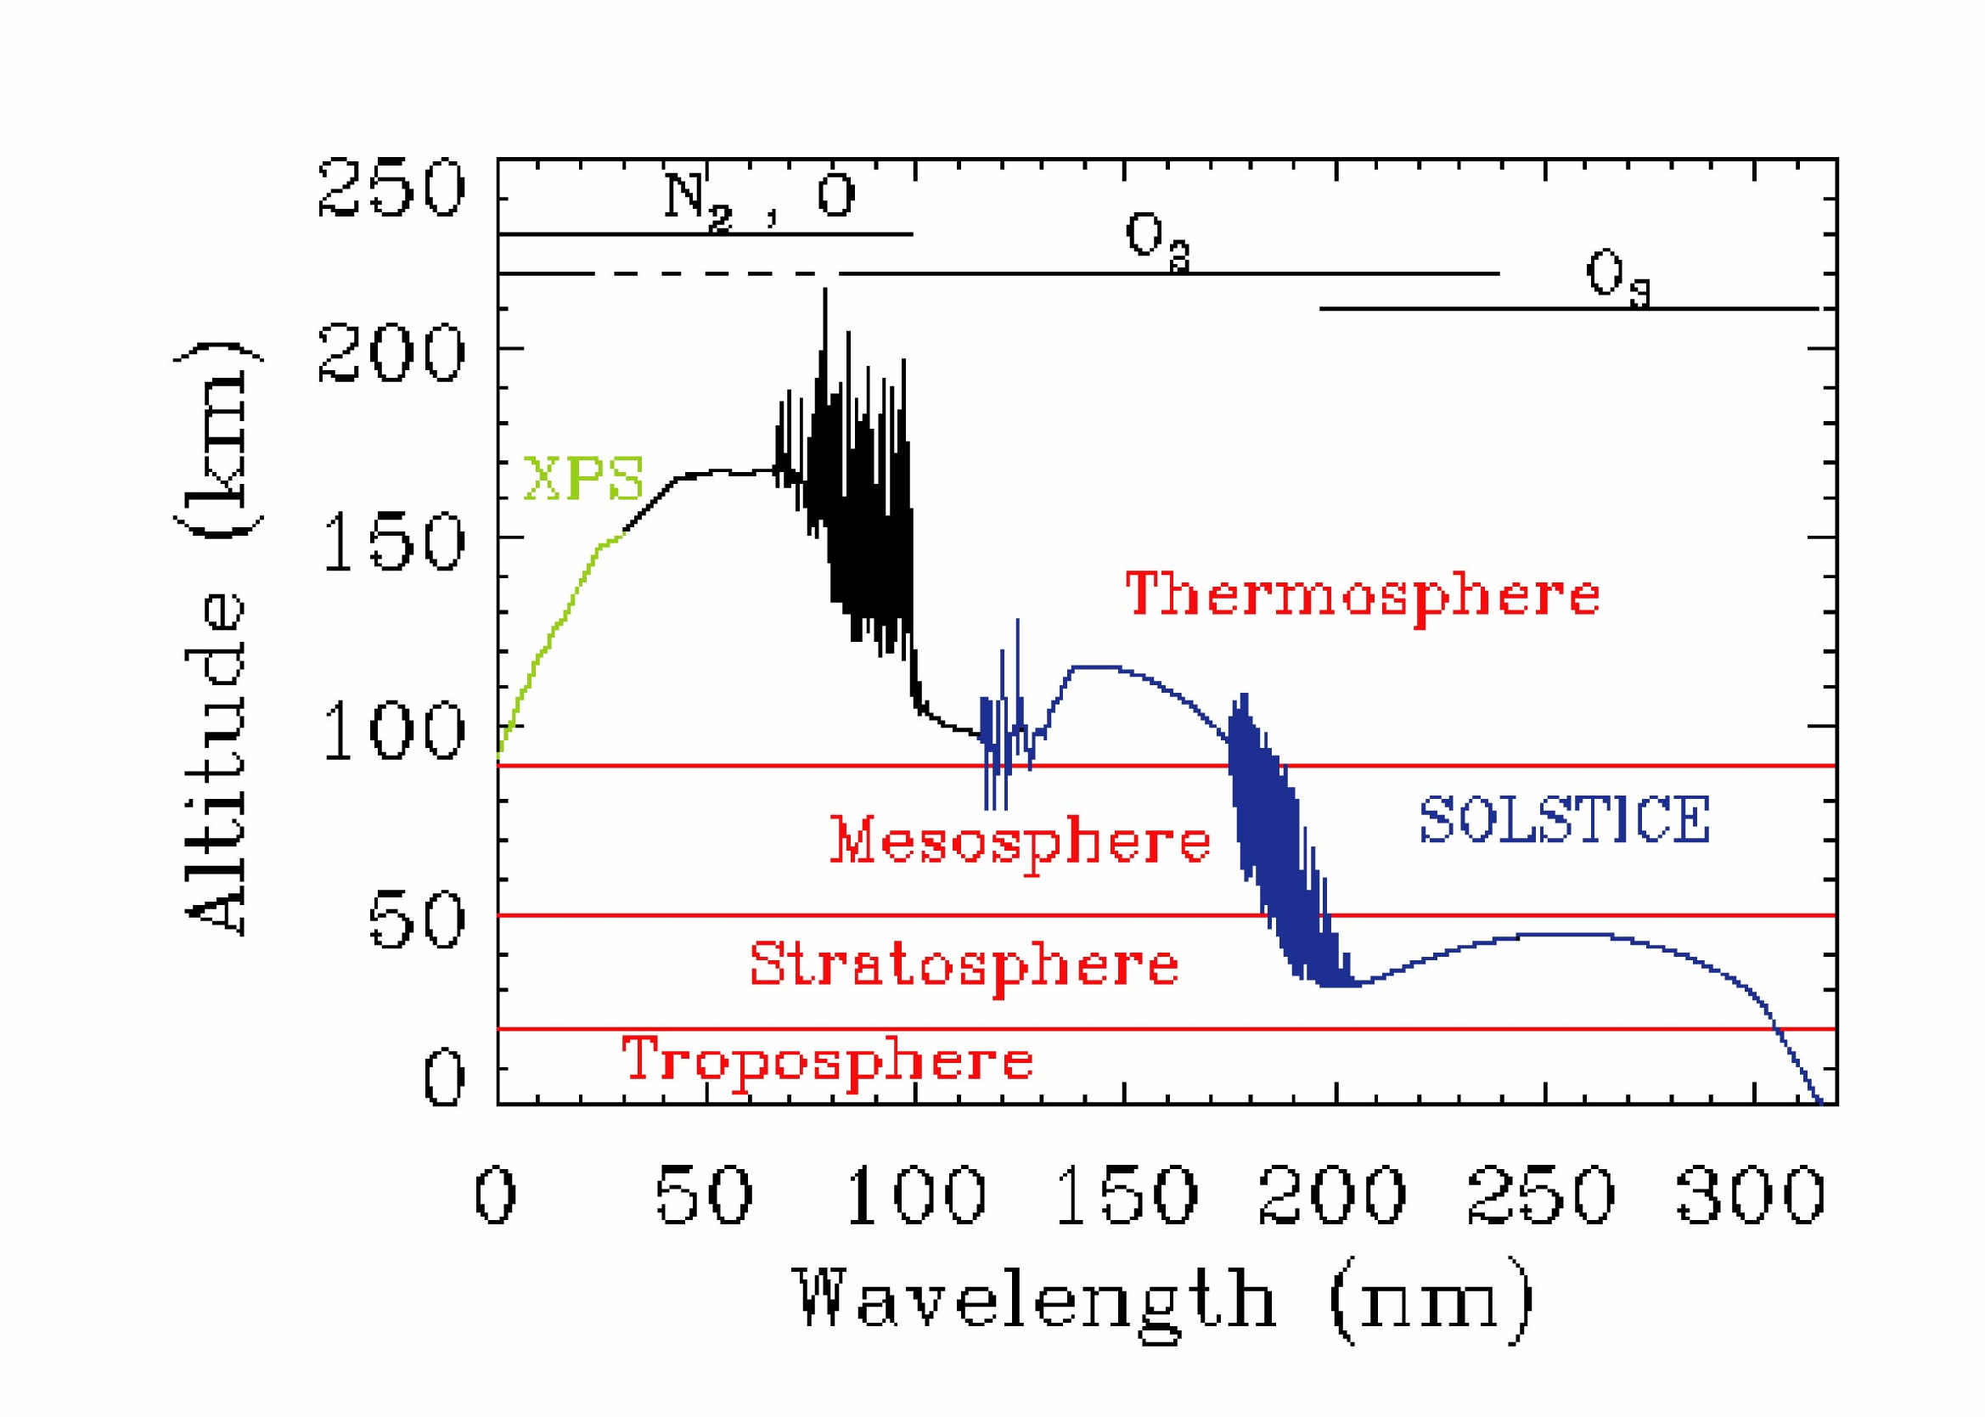
Figure 1. Altitude of optical depth unity for incoming solar spectral irradiance as a fuction of wavelength. The atmospheric species which are the dominant absorbers are indicated along the top. Adapted from Meier (1991).

Status of current missions and data records

We are currently in the fortunate situation of having a reliable source of ultraviolet SSI measurements available to the research community. Table 1 lists the current NASA missions measuring in this wavelength range. Additionally, there are NOAA EUV measurements from the GOES EUVS series (in selected broad bands), as well as two Russian and European instruments on the International Space Station: Russian Solar Patrol, 0.14-135 nm (Avakyan, 2006) and SOL-ACES, 16-140 nm (Schmidke et al., 2006). SOL-ACES was originally intended to observe the entire FUV range, but the flight unit can only measure up to 140 nm. The LYRA instrument on ESA’s PROBA2 also measures Lyman alpha and two broad EUV bands (Hochedez et al., 2006).

Spacecraft/Instrument | Wavelength Range (nm) | Mission Time Period
SOHO/SEM | 0-50 and 26-34 | 1995-present (extended mission)
TIMED/SEE | 27-194 | 2002-2011
SDO/EVE | 0.1-105 (and 121.6) | 2010-present (5 year primary mission)
SORCE/SOLSTICE | 115-300 | 2003-present (in 2nd extended mission)
Table 1. NASA missions observing SSI in the EUV and FUV wavelength range.

There is also a wealth of historical data records of SSI in this wavelength range, primarily from the two instruments on the Upper Atmosphere Research Satellite (UARS) which operated from 1991 to 2005: SUSIM (Brueckner et al., 1993) and SOLSTICE (Rottman et al., 1993). Additionally, the Solar Mesosphere Explorer (SME; Rottman, 1988) provided FUV measurements from 1981 to 1989. There are also EUV measurements from AE-E, 14-185 nm (Hinteregger, Fukui, & Gilson, 1981) and SNOE, 2-20 nm (Bailey et al., 2000).

DeLand & Cebula (2008) have worked on merging FUV datasets into a consistent composite, and their results spanning the time period of 1978 to 2005 are available for download on the LASP Interactive Solar IRradiance Datacenter (LISIRD) site http://lasp.colorado.edu/lisird. Note that all their FUV results from 1978-1982 and 1989-1992 are synthetic values derived from the 3-component model of Woods et al. (2000).

It is important to note that the proxy model extensions are based on measurements of ultraviolet SSI that extend for less than three solar cycles. There are many indications that this most recent solar minimum was unusually low with respect to irradiance (Snow, McClintock, & Woods, 2010), solar wind (Manoharan, 2010), solar magnetic field (Mewaldt et al., 2010), etc. Extrapolating the long-term behavior of the Sun from such a small sample size of solar cycles will inevitably produce large uncertainties in reconstructed irradiances and could lead to erroneous estimates of the influence of solar irradiance on the atmosphere.

Empirical proxy models and reconstructions

The datasets described in the section above have formed the basis for both theoretical and empirical models of SSI. Domingo et al. (2009) reviewed the various empirical irradiance models including the SATIRE model of Krivova, Solanki, & Unruh (2009a). Figure 2 shows the comparison of the model results to the observations of SUSIM (green) and to a composite data record from Woods et al. (2000). The Woods composite uses data from UARS SOLSTICE, SME, AE-E, and a proxy model based on the Mg II index. For times prior to 1978, it is based on an empirical model derived from the F10.7 index. The SATIRE model seems to produce the same irradiance level at each solar minimum, possibly masking any secular trend in the Lyman alpha irradiance over many solar cycles.

Space Weather inputs

The EUV and FUV wavelength ranges are entirely absorbed in the upper atmosphere (e.g. Haigh, 2007). Ultraviolet SSI controls the production and destruction of ozone (e.g. Haigh, 1999, 2007). Solar EUV photons from flares can disrupt HF communications and GPS signals. Variations in the neutral atmosphere density from ultraviolet absorption in the upper atmosphere cause variations in spacecraft drag (Bowman, Tobiska, & Marcos, 2006; Bowman et al., 2007). Solar variability near 155 nm causes variation in the molecular oxygen density in the lower thermosphere through absorption in the Schumann-Runge continuum.

Forecasting these changes in the atmosphere require near real-time knowledge of the ultraviolet SSI. Tobiska, Bouwer, & Bowman (2008) have derived a set of solar irradiance indices to simplify the input to operational space weather models. Their new Solar Irradiance Platform (SIP) (Tobiska, Bouwer, & Bowman, 2008) is an improvement over their previous model (SOLAR2000), and is used by the Air Force and other operational customers for use in satellite tracking. Ten of the fifteen solar inputs to their model come from EUV and FUV measurements (Tobiska, Bouwer & Bowman, 2008).

Guo et al. (2007) used the accelerometer data on CHAMP and determined that the thermospheric density can be best modeled using several irradiance indices: F10.7 plus the EUV and FUV indices (S_{EUV} and S_{FUV}) from Tobiska, Bouwer, & Bowman (2008). In their estimation, the EUV contributed 40% of the variation in thermospheric density, while the FUV contributed another 28% (Guo et al., 2007). So both wavelength bands must be available for the best estimation of satellite drag coefficients.

Figure 2. (Figure 6 of Krivova et al. (2009)). Solar Lyman alpha since 1974 reconstructed by the SATIRE-S model. The model captures the overall variability well, with a correlation coefficient of 0.95. However, it does poorly at reproducing the irradiance at solar minimum.

Use in Atmospheric Models

Solar ultraviolet irradiance’s influence on climate is still somewhat difficult to model in detail. There is a clear 11-year signal in temperature and geopotential height (Langematz, Matthes, & Grenfell, 2005). Stratospheric warming and dynamics can propagate down to the troposphere (Kodera & Kuroda, 2002) where they could potentially impact climate. Another mechanism for interaction between the stratosphere and the troposphere is the quasi-biennial oscillation. Labitzke (2003) demonstrated that there is a correlation between the stability of the polar vortex and the solar cycle, and Hood (2004) has shown that there is a response of tropospheric temperatures to changes in the ultraviolet SSI on rotational timescales. Having a consistent long-term dataset would be essential for understanding these mechanisms of climate change.

Mission Concepts

An EUV or FUV irradiance monitor need not be an expensive stand-alone mission. Most of the prior sensors in this wavelength range have been co-manifested with many other instruments. A logical host for a simple SSI instrument is a commercial satellite (http://www.space.commerce.gov/general/commercialpurchase/hostedpayloads.shtml). Based on our experience at LASP with the Global-scale Observations of the Limb and Disk (GOLD) mission and with the EUV sensor on the Mars Atmosphere and Volatile Evolution (MAVEN) mission, we estimate that a simple SSI monitor could be built and operated for a decade for less than $30 million. This number includes $10 million for costs of accommodation on the spacecraft, with the rest going towards design and fabrication of the instrument plus 10 years of operations. Besides the relatively low cost for a payload hosted on a commercial satellite, the faster time to move from design to orbit could quickly address any gaps in the FUV data record.

Conclusion

Extending the data record of solar EUV and FUV irradiances should continue to be a priority of the heliophysics community. SSI in these wavelength bands is the dominant source of energy input to the upper atmosphere. Understanding both the long-term (climate) and short-term (space weather) variations in the atmosphere is critical for our technological society. The National Space Weather Strategic Plan highlights understanding the solar input to our space environment as a high priority. Measurements at these wavelengths can be done on a modest budget, yet yield a great value to the scientific community. It should also be noted that the NOAA plan for operational monitoring of the EUV is to measure only limited wavelength bands and then construct the rest of the spectrum through a model. The new insights already gained from less than a year of SDO/EVE data show that we still have much to learn from observing the full spectrum.

References

Avakyan, S. (2006), Adv. Sp. Res., 37, 297.

Bailey, S. M. et al. (2000), JGR, 105, 27179.

Bowman, B. R., Tobiska, W. K., & Marcos, F. A. (2006), AIAA, 2006-6166.

Bowman, B. R. et al. (2007), JASTP, 70, 774.

Brueckner, G. E. et al. (1993), JGR, 98, 10695.

DeLand, M. T., & Cebula, R. P. (2008), JGR, 113, A11103.

Domingo, V. et al. (2009), Space Sci. Rev., 145, 337.

Guo, J. et al. (2007), JGR, 112, A10308.

Haigh, J. D. (1999), JASTP, 61, 63.

Haigh, J. D. (2007), Liv. Rev. Sol. Phys. <http://solarphysics.livingreviews.org/Artiles/lrsp-2007-2/>

Hinteregger, H. E., Fukui, K., & Gilson, G. R. (1981), GRL, 8, 1147.

Hochedez, J.-F. et al. (2006), Adv. Sp. Res., 37, 303.

Hood, L. L. (2004), GRL, 30, 2215.

Kodera, K. & Kuroda, Y. (2002), JGR, 107, 4749.

Krivova, N. A., Solanki, S. K., & Unruh, Y. C. (2009a), JASTP, doi:10.1016/j.jastp.2009.11.013

Krivova, N. A. et al. (2009b), JGR, 114, D00104.

Labitzke, K. (2003), Meteorol. Z., 12, 209.

Langematz, U., Matthes, K., & Grenfell, J. L. (2005), Memorie della Societa Astronomica Italiana, 76, 868.

Lathuillere, C. et al. (2002), Ann. Geophys., 20, 1081.

Lean, J., Picone, J. M., & Emmert, J. T. (2009), JGR, 114, A07301.

Manoharan, P. K. (2010), Highlights of Astronomy, 15, 484.

Meier, R. R. (1991), Space Sci. Rev., 58, 1.

Mewaldt, R. A. et al. (2010), ApJ Lett., 723, L1.

National Space Weather Strategic Plan (1995), Off. Fed. Coord. for Met. Services, NOAA, Silver Spring, MD.

Rottman, G. J. (1988), Adv. Sp. Res., 8, 53.

Rottman, G. J. et al. (1993), JGR, 98, 10667.

Schmidke, G. et al. (2006), Adv. Sp. Res., 37, 273.

Snow, M., McClintock, W. E., & Woods, T. N. (2010), Adv. Sp. Res., 46, 296.

Thuillier, G. & Bruinsma (2001) – Appears on page 4.

Tobiska, W. K., Bouwer, S. D., & Bowman, B. R. (2008), JASTP, 70, 803.

Woods, T. N. et al. (2000), JGR, 110, A01312.

