Spectral Signatures of Geospace Climate Change

Martin G. Mlynczak and Christopher J. Mertens
NASA Langley Research Center, Hampton, VA

Scott Jensen and Roy Esplin
Utah State University/Space Dynamics Laboratory, Logan, UT

Jeng-Hwa Yee
Johns Hopkins University Applied Physics Laboratory, Laurel, MD

Linda Hunt and Jeffrey Mast
SSAI, Hampton, VA

Stanley Solomon and Liying Qian
National Center for Atmospheric Research, Boulder, CO

A White Paper submitted to the Heliophysics Decadal Survey

November 12, 2010

1. Introduction
A fundamental prediction of climate change theory is that the Earth’s upper mesosphere and thermosphere will cool over time due to increases in the carbon dioxide (CO₂) abundance in the atmosphere caused by human activity [e.g, Roble and Dickinson, 1989]. In the upper mesosphere and thermosphere (which we will call the geospace environment) CO₂ efficiently cools the atmosphere as it essentially radiates in the cool-to-space limit. Increases in the CO₂ abundance caused by fossil fuel burning will increase the amount of infrared emission in the upper mesosphere and thermosphere nearly linearly. This will then increase the cooling of the upper atmosphere, thereby resulting in lower temperatures, all else being equal. This “global cooling” of the geospace environment is in contrast to the “global warming” expected in the troposphere and at the Earth’s surface due to increases in CO₂.
Increasing CO₂ concentrations are expected to affect the energy balance, composition, and dynamics of the upper atmosphere. As the geospace environment, particularly the thermosphere, is the first region in which the Sun begins to exert an influence on the Earth system, it is critical to understand changes in the climate of this region. In addition, a cooler upper atmosphere, at a given altitude, results in a lower density over time. This effect has significant implications for space operations ranging from satellite orbit lifetime to the tracking of space junk. Thus, in addition to scientific interests, there are substantial operational reasons for understanding climate change in Earth’s upper atmosphere. Evidence already suggests that geospace climate change is occurring [e.g, Marcos et al., 2005].
In this white paper we propose the continuation of a fundamental climate data record of the geospace environment now 9 years extant. Specifically, continued measurement of the infrared limb emission from nitric oxide (NO) and CO₂ with new infrared sensors is recommended. These measurements provide the infrared cooling rates, infrared fluxes, and total infrared radiated power that control the thermal structure and climate from 80 to ~ 275 km. Their observation over the last 9 years by the Sounding of the Atmosphere using Broadband Emission Radiometry (SABER) instrument on the NASA Thermosphere-Ionosphere-Mesosphere Energetics and Dynamics (TIMED) satellite has led to a detailed understanding of the natural variability of the geospace environment, which is the first step in understanding and determining climate change. Continuing this time series with measurements beyond the current SABER record will provide unequivocal signatures of climate change in the geospace environment over time. We also describe in this paper a new approach to using these data in the development and detection of spectral signatures (sometimes called “fingerprints”) of climate change that offer the potential for earlier detection of geospace climate change than traditional parameter retrievals. Lastly we discuss considerations for continuing these measurements with lightweight derivatives of the SABER instrument and the potential to incorporate these measurements as part of other missions.

2. The SABER Infrared Time Series Record
The upper mesosphere and thermosphere cool to space through infrared radiation emitted by carbon dioxide (15 μm), nitric oxide (5.3 μm) and atomic oxygen (63 μm). Carbon dioxide and nitric oxide compose about 90% of the total infrared power radiated from the thermosphere. As such, these two emission features are fundamental to controlling the climate and energy balance of the geospace environment (80 to 275 km). The CO₂ and NO emissions have been measured for nearly 9 years by the SABER instrument (launched December 7, 2001; science operations commenced January 2002) on the NASA TIMED satellite. The instrument has operated nominally recording approximately 98% of possible science data. The CO₂ emissions are routinely observed up to 140 km and the NO emissions have been observed up to at least 275 km during disturbed conditions.
The SABER infrared record to date is remarkable. Figure 1 shows the time series from January 2002 through October 2010 of daily global infrared power (Watts) radiated from the geospace environment (100 to 250 km) by NO and CO₂. The 60-day running mean is also shown. Sixty days is the time required for the TIMED satellite to precess through all local times. Also shown are the daily and 27-day averages of the F10.7 solar radio flux. Figure 2 displays the same data but from January 2009 to the present in order to show more clearly the behavior at the onset of solar cycle 24.
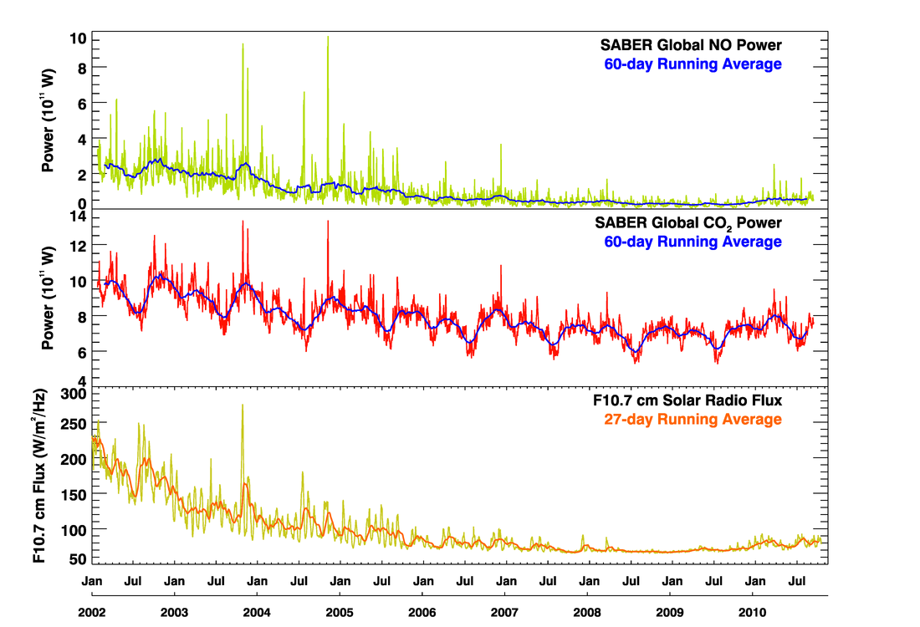
Figure 1. Time series of NO and CO₂ daily infrared power radiated from the thermosphere between January 2002 and October 2010 along with the F10.7 solar radio flux. After Mlynczak et al., [2010a].

Variability in the data on timescales ranging from days to years is evident. The “spikes” in the data are not noise but are in fact the response of the thermosphere to geomagnetic storms. The long-term decline in the infrared power is due to the nominal “11-year” solar cycle, which was very prolonged in cycle 23 through 2008. Variability on annual and semi-annual timescales is visually evident in the CO₂ power. Variability on timescales associated with the solar rotation period and its harmonics is also found in the data [Mlynczak et al., 2008].
To further illustrate the variability of the infrared cooling of the thermosphere we have deseasonalized (essentially a subtraction of the mean power) the NO and CO₂ time series shown in Figures 1 and 2 for each 60-day yaw cycle observed to date, with the results shown in Figure 3. The deseasonalized NO and CO₂ power clearly show the decrease in infrared cooling (radiated power) from the start of the mission in 2002. The decrease continues in both NO and CO₂ until the middle of 2008 at which time a minimum of infrared cooling is reached. Starting in mid- to late 2009 the deseasonalized mean power starts to increase. The increase is indicative of increasing infrared power corresponding to an increase in thermospheric temperatures at the onset of solar cycle 24 [Mlynczak et al., 2010b]. Note that the deseasonalized power is negative some of the time. This is simply a reflection of the fact that the power at some times is less than the mean power. The NO and CO₂ cooling rates shown in Figure 3 have a linear correlation coefficient of 0.985.
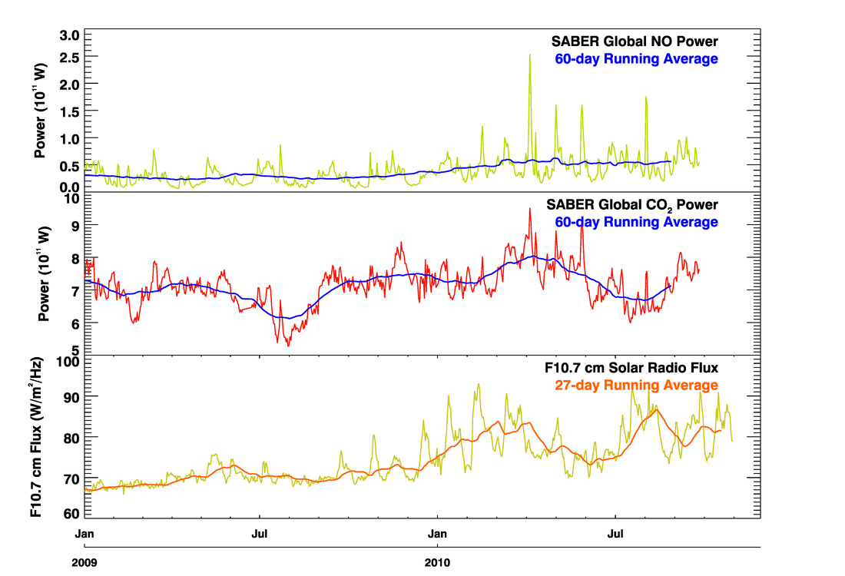
Figure 2. Same as Figure 1 but expanded from January 2009 through October 2010 to show detail. The increase in solar activity is visually evident in the F10.7 solar radio flux and in the NO power 60-day running mean. After Mlynczak et al., [2010b].
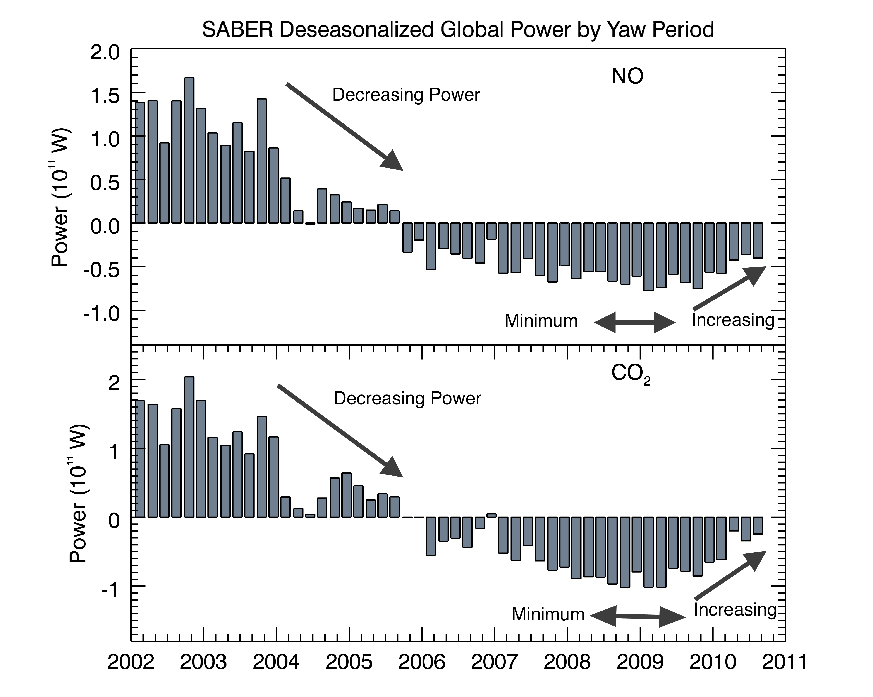
Figure 3. Deseasonalized time series of infrared power from NO and CO₂ in the geospace environment. The data indicate increasing infrared power (increased infrared cooling) since ~ mid 2009, which correlates with increasing solar activity. After Mlynczak et al., [2010b].
From the perspective of measurement of geospace climate parameters, the infrared emissions from which cooling rates, fluxes, and power can be derived are fundamental. The measured infrared limb radiance constrains the derived infrared cooling rates [Mlynczak et al., 2010a]. In addition, these infrared parameters are directly measurable, i.e., they are not generated by inversion of a non-linear radiative transfer equation. Furthermore, the infrared emissions themselves constitute a climate benchmark [e.g., Anderson et al., 2004]. These benchmarks will in time offer a spectral signature associated with climate change in the geospace environment.

3. Infrared spectral signatures of geospace climate change
The climate of the Earth’s atmosphere is determined by the energy input from the Sun and the energy radiated from the Earth. Climate change occurs when the energy budget changes due to natural or possibly anthropogenic forcings. These forcings cause the climate system to adjust, sometimes engendering feedbacks that amplify or mitigate the forcings, resulting in a new climate state that is warmer or cooler than the original. The amount of carbon dioxide has been increasing in Earth’s atmosphere since the Industrial Revolution began in the late 1700’s, providing a climate forcing of anthropogenic origin. Carbon dioxide is radiatively active and is a principal factor in determining Earth’s climate from the surface to the thermosphere.
The key question going forward is how to detect geospace climate change. We propose, based on the analysis and understanding of the infrared radiative features observed for the past 9 years, that measurement of the time series of infrared cooling emissions from the thermosphere will provide a distinct spectral signature from which climate change will become obvious and irrefutable, and which can be used to advance modeling and prediction of future climate change.
The measurement of infrared spectral signatures of climate change has been discussed in the literature relating to lower atmosphere (tropospheric) climate for nearly 30 years. Kiehl [1983] and Charlock [1984] noted that distinct spectral signatures would be evident in changes in the infrared radiance emitted by the Earth and its atmosphere, and that these could be observed from orbiting satellites. These spectral signatures could further be associated with the forcing of climate due to the anthropogenic increase of CO₂.
Since the pioneering work of Kiehl and Charlock, a number of other studies have advanced the concepts of spectral signatures of climate change [e.g., Goody et al., 1995; Slingo and Webb, 1997]. Harries et al. [2001] showed convincingly the increase in the greenhouse effect due to methane using spectral signatures of infrared radiance spectra taken 27 years apart from satellite spectrometers. More recently, Huang and Ramaswamy [2009] and Huang et al. [2010] have shown that distinct infrared spectral signatures associated with specific aspects of climate change (e.g., cloud height, tropospheric water vapor) can be uniquely determined.
Today the concept of using spectral signatures to identify and attribute tropospheric climate change is firmly accepted and is in fact the foundation of the Climate Absolute Radiance and Refractivity Observatory (CLARREO) satellite mission defined in the Earth Science Decadal Survey [National Research Council, 2007]. The CLARREO mission will measure Earth’s infrared emission spectrum and the spectrum of reflected solar radiation from the Earth. The primary CLARREO data products are the emitted and reflected radiance spectra. These radiance measurements and the spectral signatures and changes derived from their time series will elucidate the degree of climate change in the troposphere over time. The CLARREO mission is now being developed by the NASA Langley Research Center and at this writing is days away from being confirmed and moved into formulation (Phase A) by NASA.
The ideas relating to the measurement of infrared spectral signatures to determine climate change in the troposphere can be readily and more easily applied to the geospace environment. Spectral separation of the different cooling features is complete in the upper atmosphere as opposed to the troposphere in which water vapor and carbon dioxide emit throughout the infrared spectrum, thus necessitating the measurement of nearly the entire infrared spectrum for the CLARREO mission. The NO and CO₂ cooling are spectrally distinct (5.3 μm and 15 μm) and are measured unequivocally with little or no interfering emissions [Mlynczak et al., 2010a]. Thus the measurement of these two emission features offers an essentially pure time series of the fundamental processes controlling the climate and energy balance of the geospace environment. These emissions will yield the clear signal of the geospace climate response due to forcing by increases in carbon dioxide. The spectral fingerprint will be manifest as a consequence of increased CO₂ abundance and decreasing temperature. In the long term the increasing CO₂ abundance will result in more measured radiance from the thermosphere despite a modest (~10 to 15%) decrease associated with cooler temperatures. In contrast, NO emission will decrease much more rapidly (assuming no change in NO abundances) due to greater temperature sensitivity than that of CO₂. This is a fundamental expectation from infrared radiation physics. The sensitivity of NO to temperature is ~ exp(-2700/T) while the sensitivity of CO₂ is ~ exp(-960/T). The greater sensitivity of NO is due to the higher energy associated with its quantum transition at 5.3 μm vs. the energy of CO₂ at 15 μm.
The application of infrared spectral signature determination in geospace climate is an emerging concept and does require more detailed study. We suggest modeling studies especially to investigate the anticipated chemistry changes associated with NO in particular and to determine in more detail the expected signature of NO infrared emission change associated with geospace climate change. Furthermore, the timescales for natural variability and trend detection need to be more fully defined. The approach for doing this with infrared measurements has been developed by Leroy et al., [2008] and the existing SABER data can be used. We emphasize that because the infrared radiance is a direct observable, whose uncertainty is quite small and can be ascertained by on-board calibration, trends in radiance (and derived fluxes and cooling rates) will result in detection and attribution of climate change in much less time than that derived from other remotely-sensed, retrieved parameters, such as temperature or species concentrations. This is because the uncertainty in the radiance is substantially less than in retrieved parameters, and time to detect trends is directly strongly dependent on the uncertainty of the parameter being trended.

4. Instrument Concept
SABER is a filter radiometer that measures infrared radiation in 10 spectral bands. Interference filters in front of the detectors largely define the spectral response of the instrument. In the immediate future a key factor to continuing the infrared climate data record is to have a new instrument overlap the current SABER instrument. Analogous to solar irradiance measurements, differences in instrument calibrations and spectral responses can be best dealt with by having overlap of successive instruments. We note that technology for upper atmosphere measurements has yet to include on-board systems to enable on-orbit absolute calibration and spectral response such as those now developed for the CLARREO mission [e.g., Dykema and Anderson, 2006].
With this in mind, the Langley Research Center and the Space Dynamics Laboratory of the Utah State University have been working on a lightweight derivative of the SABER instrument. The goal has been to reduce the mass of the instrument to approximately one-half the value of the TIMED/SABER instrument (i.e., from ~ 75 kg to ~ 35 kg) with little or no loss in sensitivity from the current instrument. A corresponding reduction in instrument power from ~ 75 W to ~ 35 W is also feasible.
In Figure 4 below we show the optical system for the lightweight derivative of the SABER instrument, herein referred to as the Middle Atmosphere Sounder and Thermal Emission Radiometer (MASTER) instrument. It is an on-axis, re-imaging telescope preceded by a plane scan mirror. Its entrance aperture is 100 mm in diameter, and its F/number at the detectors is F/2. A picket-fence, tuning fork chopper is located at the focus of the fore-optics, which are re-imaged at the detector. As demonstrated by SABER, this optical system configuration has excellent stray-light rejection, having been measured to be as good as an off-axis optical system. This unusual stray-light rejection capability for an on-axis optical system results from an unconventional cold Lyot stop design that blocks stray light from the central obscuration, the spider vanes, and from the aperture stop. This Lyot stop minimizes background photon noise by preventing the detectors from seeing any low emissivity surface except the 75K Lyot stop. The on-axis configuration is also mass efficient, when compared to an off-axis system, due to the inherent strength of its cylindrical shape. The radiometric sensitivity of this on-axis optical system has been shown by analysis to be significantly better than an off-axis optical system.
The largest contributor to mass reduction will result from changing the method of mounting and cooling the telescope. This change accounts for most of the mass reduction of the support structure, the scan and baffle, the re-imager optics, the fore optics, and MLI blanketing assemblies. This change will be made possible by shortening the baffle that precedes the scan mirror in the optical path. Making this baffle shorter in MASTER, when compared to SABER, results in a negligible decrease in stray light rejection in exchange for a very large decrease in mass.

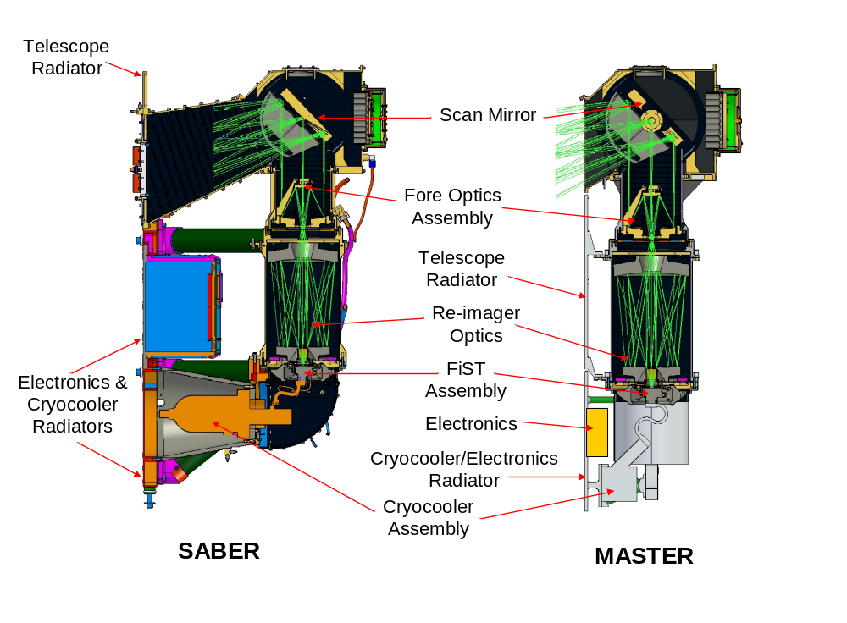
Figure 4. SABER and MASTER Optical System Comparison

The length of the SABER baffle was selected early in the SABER program to get every bit of stray light rejection possible; however, in hindsight, the SABER baffle length could have been shortened with only a negligible decrease in its stray light rejection capability. The shorter baffle in front of the scan mirror will enable the MASTER telescope to be directly attached to its radiator rather than to the isolator legs as was the case for SABER. The cooling path for the MASTER telescope will be radial along the length of the instrument rather than longitudinal from the back of the instrument to the front as it is in SABER. This change in the cooling path reduces the wall thickness and hence mass required for thermal conduction in the optics. It also reduces the parasitic heat load that further reduces the mass by reducing needed radiator area. Additional mass reductions will be achieved by incorporating composite materials in the scan and baffle assembly and also by light-weighting the mirrors.
The next largest contributor to mass reduction results from updating and improving the packaging of the electronics and from advances in cryocooler technologies over the past decade. The electronics and cryocooler radiator is also reduced in size due to the reduced power needs to operate the next generation cryocooler and electronics. The smaller packages of these components also reduce the parasitic heat loading on the radiators, once again reducing the radiator size from SABER heritage. Finally, radiometric analysis of the MASTER design shows negligible change in predicted noise performance as compared with the achieved SABER flight performance. Anticipated mass and power specifications for MASTER and SABER are given in Tables 1 and 2.

Table 1. MASTER and SABER mass comparison.
Assembly Name | SABER Mass (kg) | MASTER Mass (kg) | Mass Savings (kg)
Support Structure | 14.04 | 1.10 | 12.94
Instrument Electronics | 11.51 | 2.18 | 9.33
Cryocooler | 11.65 | 4.02 | 7.64
Scan and Baffle | 15.98 | 10.94 | 5.04
Re-imager Optics | 7.27 | 5.59 | 1.69
MLI Blanketing | 2.20 | 1.50 | 0.70
Fore Optics | 2.33 | 1.67 | 0.65
Hardware/Cables | 7.71 | 5.77 | 1.94
TOTAL MASS | 72.69 | 32.77 | 39.93

Table 2. MASTER and SABER power comparison.
ASSEMBLY NAME | SABER Power (W) | MASTER Power W | Power Savings (W)
Cryocooler | 35.5 | 16.3 | 19.2
Heater | 13.8 | 5.0 | 8.8
Analog Controllers | 10.0 | 6.7 | 3.3
Signal Processing | 5.5 | 2.3 | 3.2
C & DH | 5.7 | 4.1 | 1.6
Housekeeping | 1.8 | 0.6 | 1.2
TOTAL POWER | 72.3 | 35.0 | 37.3

5. Summary and Additional Considerations
Geospace climate change is a frontier of scientific exploration. A unique, fundamental climate data record spanning 9 years from SABER now exists. It is proposed that this record be extended, especially the measurement of the NO and CO₂ emissions between 80 and 275 km. It is further proposed that the spectral signature techniques, which are now the foundation for space-based detection of tropospheric climate change, be applied to the infrared observations the geospace environment. These techniques, because they use the measured infrared radiances, offer the potential for detection and attribution of climate change in a much shorter time than conventional parameter retrievals. This is due to the inherently higher accuracy of the radiance measurements as compared to the accuracy of parameters retrieved from the radiance measurements. Lastly, the proposed MASTER instrument, a lightweight derivative of the SABER instrument, can be developed for a flight of opportunity. The MASTER instrument could also be part of a focused mission to study the ionospheric E-region, as discussed in the White Paper by Mertens et al. [2010] submitted to the Heliophysics Decadal Survey call.

References
Anderson, J. G., et al., (2004), Absolute, spectrally resolved thermal radiance: a benchmark for climate monitoring form space, J. Quant. Spectrosc. Rad. Trans., 85, 367-383, doi:10.1016/S0022-4073(03)00232-2
Charlock, T. P., (1984), CO₂ induced climatic change and spectral variations in the outgoing terrestrial infrared radiation, Tellus, 36B, 139-148. 1984
Dykema, J.A., and J.G. Anderson, (2006), A methodology for obtaining on-orbit SI-traceable spectral radiance measurements in the thermal infrared, Metrologia 43, 287-293.
Goody, R. M., R. Haskins, W. Abdou, and L. Chen, (1995), Detection of climate forcing using emission spectra, Remote Sensing and Earth Observation, 5, 22-32.
Harries, J. E., et al. (2001), Increases in greenhouse forcing inferred from the outgoing longwave radiation spectra of the Earth in 1970 and 1997, Nature, 410(6826), 355–357, doi:10.1038/35066553
Huang, Yi, V. Ramaswamy, 2009: Evolution and Trend of the Outgoing Longwave Radiation Spectrum. J. Climate, 22, 4637–4651. doi: 10.1175/2009JCLI2874.1
Huang, Y., S. Leroy, P. J. Gero, J. Dykema, and J. Anderson (2010), Separation of longwave climate feedbacks from spectral observations, J. Geophys. Res., 115, D07104, doi:10.1029/2009JD012766.
Kiehl, J. T., (1983), Satellite detection of effects due to increased atmospheric carbon dioxide, Science, 222, 504-506.
Leroy, S., et al. (2008), Testing climate models with thermal infrared spectra, J. Clim., 21, 1863–1875, doi:10.1175/2007JCLI2061.1.
Marcos, F. A., J. O. Wise, M. J. Kendra, N. J. Grossbard and B. R. Bowman, (2005), Detection of a long-term decrease in thermospheric neutral density, Geophys. Res. Lett., 32, L04103, doi:10.1029/2004GL021269.
Mertens C. J., et al., (2010) Ionospheric E-Region Chemistry and Energetics, White Paper submitted to the Heliophysics Decadal Survey
Mlynczak, M. G., et al. (2008), Solar‐terrestrial coupling evidenced by periodic behavior in geomagnetic indexes and the infrared energy budget of the thermosphere, Geophys. Res. Lett., 35, L05808, doi:10.1029/2007GL032620.
Mlynczak, M. G., et al. (2010a), Observations of infrared radiative cooling in the thermosphere on daily to multiyear timescales from the TIMED/SABER instrument, J. Geophys. Res., 115, A03309, doi:10.1029/2009JA014713.
Mlynczak, M. G., et al. (2010b), Evidence for Onset of Solar Cycle 24 from Observations of Increasing Radiative Cooling of the Thermosphere, Geophys. Res. Lett., in preparation.

National Research Council, 2007, Earth Science and Applications from Space: National Imperatives for the Next Decade and Beyond, 456 pp., http://www.nap.edu/catalog.php?record_id=11820
Roble, R. G., and R. E. Dickinson (1989), How will changes in carbon dioxide and methane modify the mean structure of the mesosphere and thermosphere?, Geophys. Res. Lett., 16(12), 1441-1444.
Slingo, A., and M. Webb, (1997), The spectral signature of global warming, Q. J. R. Meteorol. Soc., 123, 293-307.

